Garage Door Safety Month 2026 Member Social Posts

Post / Text | Image
Yor garage door is the largest moving part of your home. Make sure it operates safely during Garage Door Safety Month. Visit IDA’s Consumer Page for simple safety tips, and if something doesn’t seem right, give us a call for an inspection and quote.  #GDSM26  https://bit.ly/3xRCIGb | 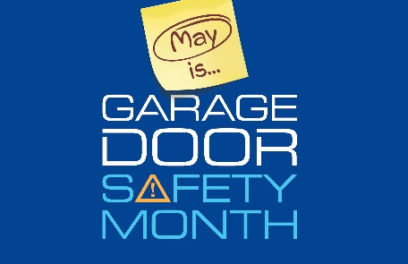
If your garage door isn’t opening, closing, or operating smoothly, don’t wait. Contact us for a professional evaluation before a small issue becomes a safety concern. #GDSM26 | Insert picture of company, assisting a customer, or your contact information.
This #GarageDoorSafety video helps homeowners understand key safety risks and when it’s best to call a trained technician. 📞 We’re always here to help. #GDSM26 | https://www.youtube.com/shorts/kLb06LqfRv0
During #GDSM26, take a moment to confirm that the company you hire is legitimate. Reliable garage door professionals maintain consistent contact information and a proven service record. 👷#GDSM26  https://doors.org/find-a-qualified-professional/consumer-resources/ | Insert picture of your business  Include phone number, website or email either in text, bio, or photo itself.
Are you listening to what your garage door is telling you? 👂 Watch this #GarageDoorSafety video to learn which sounds are normal and which may indicate a problem. Persistent squeaks, grinding, or bangs mean it’s time to call a professional.  #GDSM26 | https://www.youtube.com/shorts/Lwd31lRWLPs
If you suspect fraud or misleading service practices, report it through IDA’s Consumer Resources and then reach out to us for honest, professional service you can trust. #GDSM26 | https://doors.org/find-a-qualified-professional/consumer-resources/
Garage door safety doesn’t have to be complicated. This infographic walks through four simple steps to help homeowners stay informed: Look, Listen, Learn, and Remember. A few minutes today can help prevent bigger problems tomorrow.  #GDSM26 | 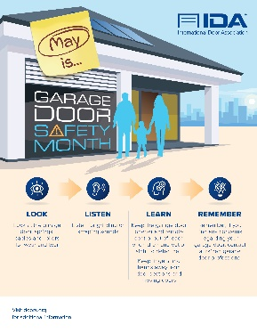
Unsolicited repair offers and scare tactics are common at this time of year. Protect yourself by choosing a qualified, established garage door dealer. Call us anytime for quality service. #GDSM26 | Insert picture of your business  Include phone number, website or email either in text, bio, or photo itself.
[Insert Company Name] delivers dependable service year‑round. Keep us in mind for repairs, maintenance, or inspections whenever you need a trusted garage door professional. #GDSM26 | Company Logo or IDA Graphic Below  