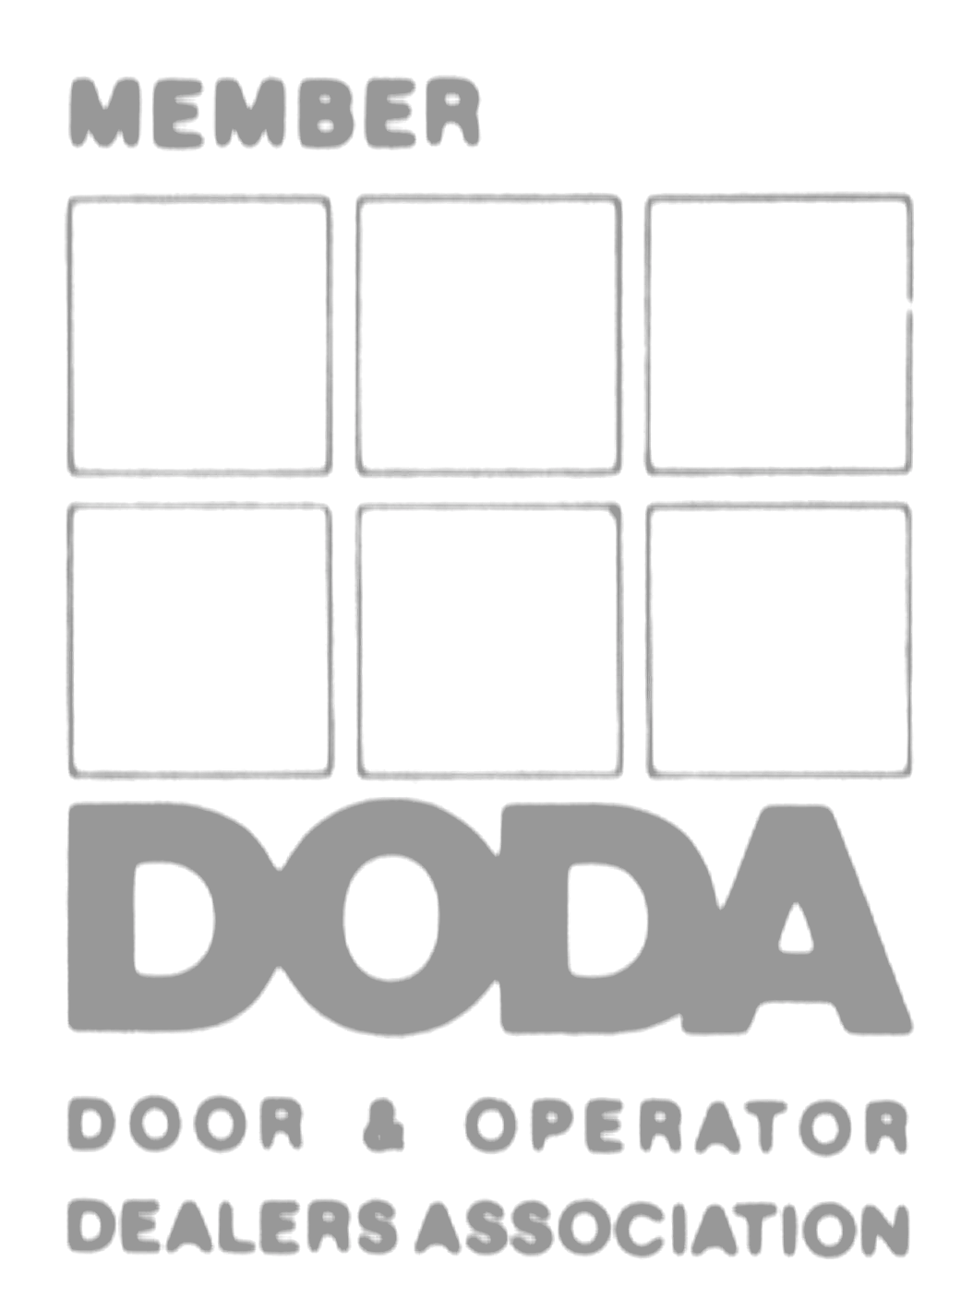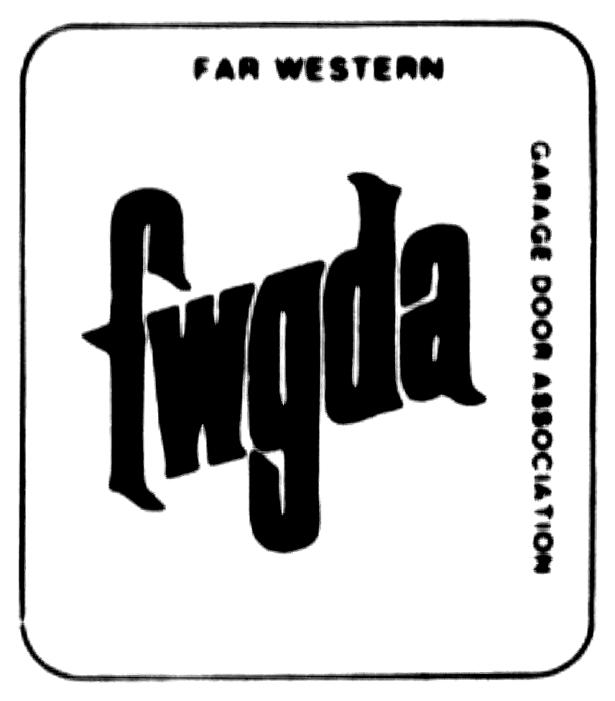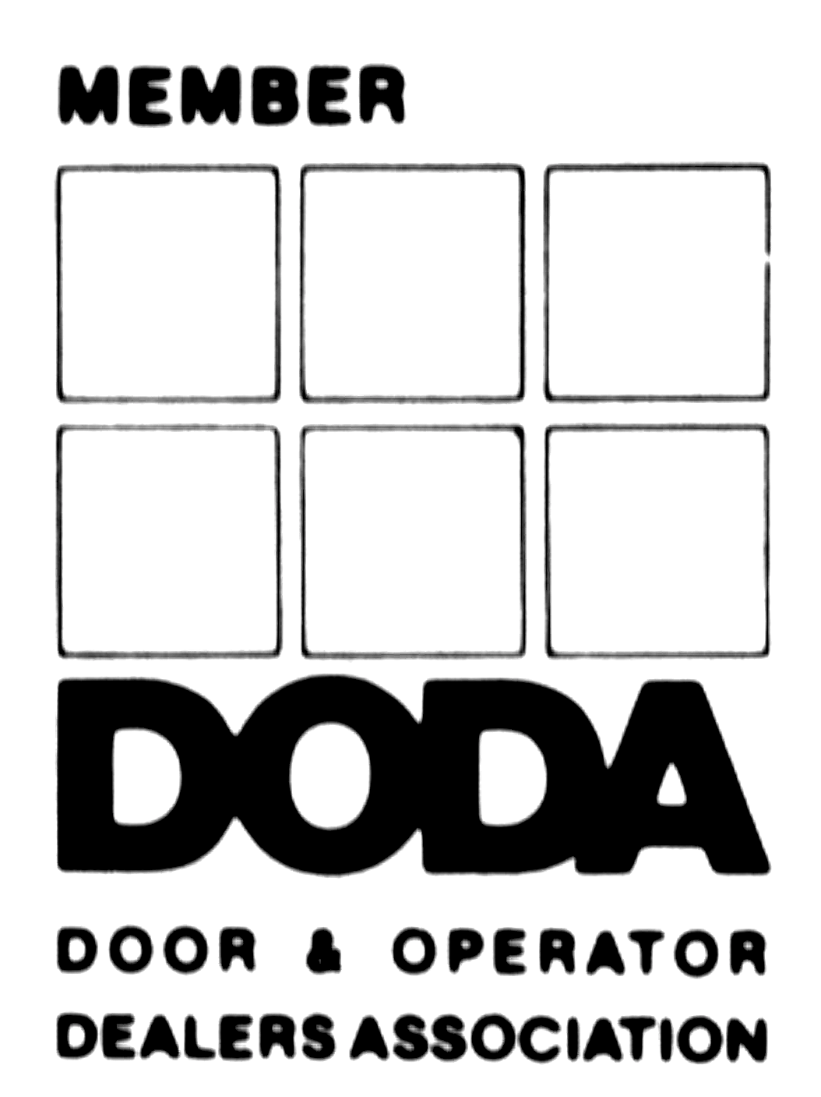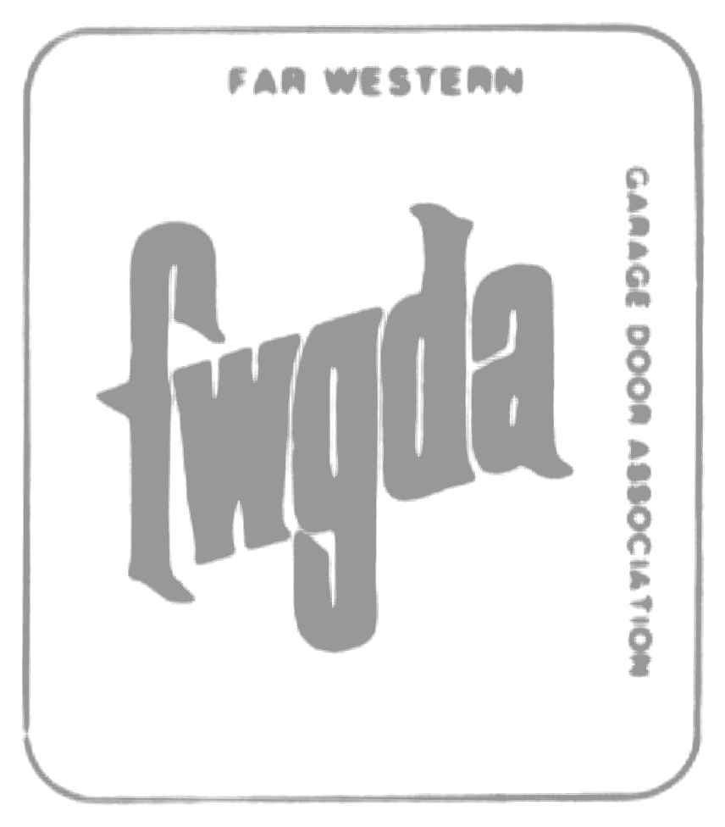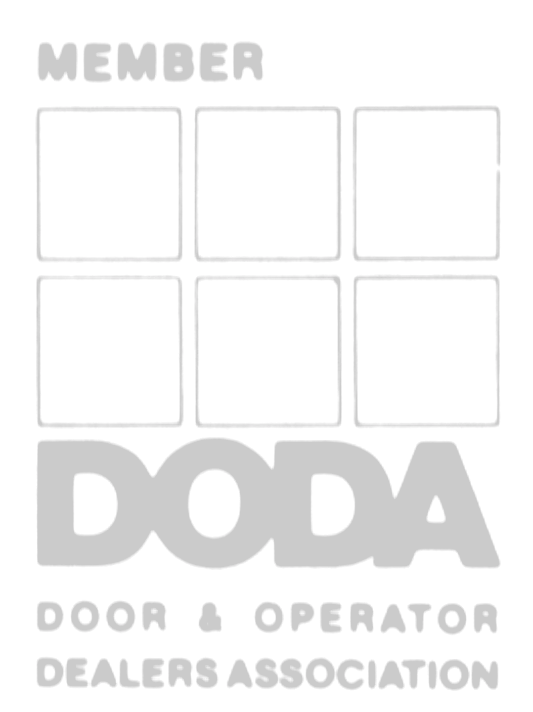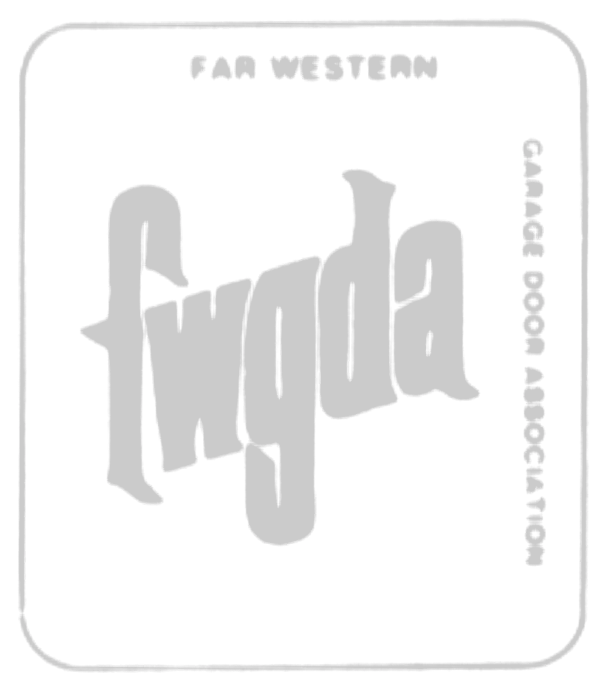

**Forward**



This book is dedicated to all who have been members of the door dealer associations and the contributions that each has made to the advancement of OUR industry.

September 2015

**Acknowledgments**



The compilation of this book would not have been possible without the efforts of many people. As Chairman of the Heritage Committee, I would like to personally acknowledge Michael Overbay, and Joyce Clingman for pouring through 30,000+ documents and the Heritage Committee mem- bers for their efforts in getting this to print.

And finally, a special thank you to the Past Presidents who shared their reflections, thoughts and leadership in bringing us to where we are today.

Theodore J. Billman

2002 Heritage Committee Chairman

**Preface**



The International Door Association was created with the merger in 1996 of the Far Western Garage Door Association and the Door & Operator Dealers Association. It’s colorful history reaches back to March, 1967, and is reflective of the numerous changes realized by the door systems industry.

The most common IDA denominator is people, both those who have led the association, and those who have supported it in many other ways. It is because of many courageous volunteer visionaries that the predecessor associations (FWGDA and DODA) were organized. It was that same vision that ultimately brought the two groups together, creating a meaningful and valuable international organization.

The purpose of this document is to capture the history of IDA for current and future reflection. By knowing our history, by examining our foundation, we will continue to build a strong and viable door dealer association far into the future.

This document is dedicated to all of the volunteers who have helped mold an association of which we all are proud to call our own.

This history document was derived from a multitude of sources. We apologize if any key person has been omitted or perhaps a name misspelled. However, the document will be ever changing – it is a “living document.” If you have a suggestion for a change or addition, just let us know and we’ll be glad to accommodate you. This document is dedicated to all of the volunteers who have helped mold the association of which we all are proud to call our own.

**Table of Contents**



Far Western Garage Door Association 5

Door and Operator Dealers Association 35

International Door Association 59

Past President’s Comments 69

Board Photos 90

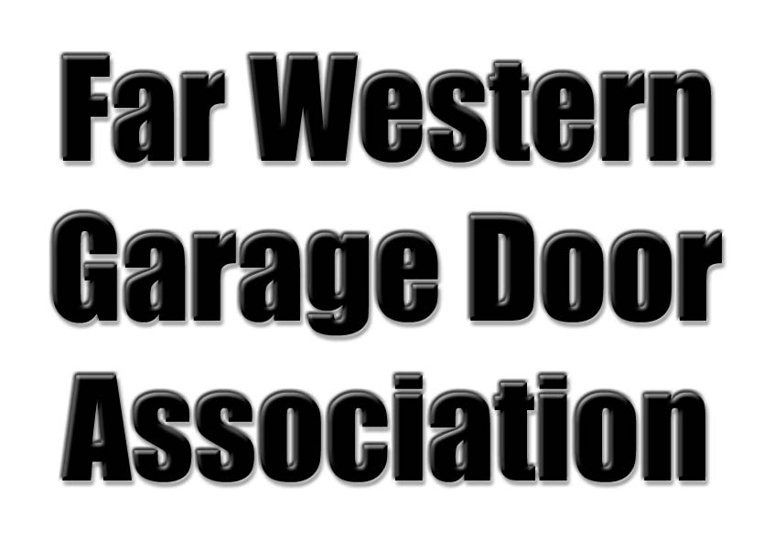

Heritage of the International Door Association 5

1964-1967



President: Ralph Morgan

VP: Ether Moore

Sec/Treasurer: Roy L. Crawford

Directors: Fred Walburn, John Kemp, Dave Martin, Russell L. Smith, Ray H. Williams, Marvin Miller, Paul M. Halopoff, Marty Berlin, Roy F. Young

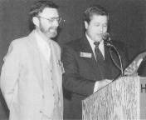

Roy Crawford, receiving plaque in 1989

Roy L. Crawford was a man with a vision, and a mission, and was highly responsible for the creation of the Far Western Garage Door Association in 1964. His vision was to develop an avenue for professionals of the garage door industry to network and share knowledge. His vision became a reality, and has benefited literally thousands of garage

door dealers, and the companies that provide them products and services.

The Far Western Garage Door Association’s annual convention was designed to bring dealers and product and service providers together in one location. The annual event provided an opportunity for dealers to share their concerns and find solutions for their problems. The Convention also became an avenue to educate door dealers and install- ers.

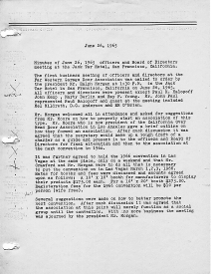

The inaugural meeting of the FWGDA officers and directors was conducted on June 26,

1965 in the Jack Tar Hotel, San Francisco, California. During the 1965 Convention, it was decided to conduct future Conventions in Las Vegas. The membership also agreed that until a charter was drafted, the FWGDA would continue to operate as a social group.

1967-1968



President: D. Ted Farrell

1st VP: Ether Moore

2nd VP: Dave Martin

Sec/Treasurer: Roy L. Crawford

Directors: Ralph Morgan, Howard Payne, Neil Rogers, Paul Kanaga, Fred Walburn, Paul Halopoff, John Kemp, and Jim Leech

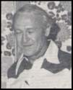

**Ted Farrell**

March 31, 1967 marked the date the bylaws and corporate seal for the Far Western Garage Door Association were officially adopted. The next day during the annual meeting of members, a new slate of officers and directors were elected to serve for the new year.

The year proved to be an exciting one. The theme for the next convention was decided, “Garage Doors…Yesterday, Today and To- morrow.” A golf tournament was planned, and the event’s speakers, workshops, and seminars were enhanced. During the year, the committee activity was greatly expanded to focus on regulatory issues.

The FWGDA formed a committee to work with the Remote Control Manufacturers Association in Chicago. The focus of the committee was related to operators and radio control standards in the western states.

Communication to the membership became a high priority, and as a result, a quarterly newsletter was created.

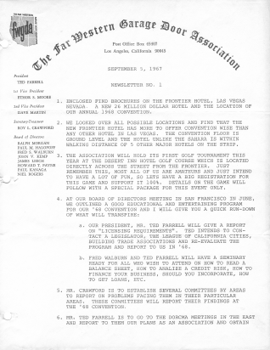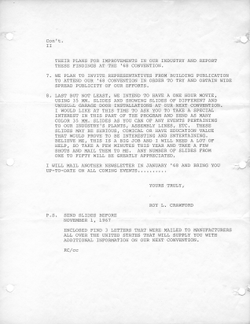

1968-1969



President: Dave Martin

1st VP: Paul Halopoff

2nd VP, Fred Walburn Secretary/Treasurer: D. Ted Farrell Directors: Bob Ford, Bill Hittaker, Al Rankin, Jim Leech, Howard Payne, Ray Williams, Bob Martinez, and Ether Moore

During this period, the leadership focused on the annual convention and created a number of event improvements. In 1969, a Spouses Program was added, and to make identifica- tion easier, new ID cards were developed using pressure sensitive emblems affixed to “Frontier” chips! Dealers wore blue, manu- facturers red, and guests wore green.

The 1969 also featured a sales seminar immediately following the business meeting. The seminar was presented by five experts in Door Operators, Radio Controls, One-Piece Doors, Sectional Doors, and Hardware.

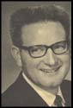

**Dave Martin**

“We in the garage door industry must get together. The only sensible way to approach these problems is to pool our ideas and experiences.” Under Dave’s direction, there was a very successful seminar program at

the 1969 convention.

**Dave Martin**

Dave was the first president from outside California. He made an appeal to all door companies to join together in order to cope with the growing problems of government interference in business. In an appeal made in the convention report of 1969, Dave

stated, “The business of opening and closing garage doors is becoming more and more complex. Whether we like it or not, we are faced with increased restrictions in building codes, licensing and requirements for more and better records.”

1969-1970



President: Dave Martin

VP: Ray Williams, James Leech, Paul Halopoff, Ted Farrell Secretary/Treasurer: Roy L. Crawford Directors: Bob Ford, Bill Whittaker, Al

Rankin, Howard T. Payne, Bob Martinez, Ether Moore, Chuck Hempenstall, and Harry Steven

This year will be long remembered as the year of the “storms.” Because of history- making rains the west encountered during

the year, many people initially cancelled their plans to attend the convention. The associa- tion was preparing for the worst, but the registration was swamped, and the 1969 convention broke all previous attendance records.

Of utmost importance to the industry in 1969 was the opening and closing of garage doors! Dealers were being faced with in-

creased restrictions in building codes, licens- ing, and requirements for better record keep- ing. It was stated that the industry “must get together and pool their resources, ideas, and experience to approach these problems.”

The keynote speaker for the 1969 convention was HUD Secretary, George Romme. He stated, “Voluntary cooperation is a social mechanism through which individuals and groups join forces to solve problem that are too big for individual action.”



**Dave Martin**

1970-1971



President: Ray Williams

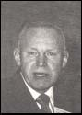

Vice Presidents: Paul Halopoff, Howard Payne, Chuck Hempenstall Secretary/Treasurer: Roy L. Crawford Directors: Ether Moore, Al Rankin, Bob Martinez, Clarence Yeager, Bud Truman, Neil Rogers, and Jerry Kenaga

In the beginning of this new decade, Presi- dent Crawford was notified by the State of California that the FWGDA might not be al- lowed to function as a non-profit trade associa- tion.

The Board voted to conduct the 1997 con- vention at the Disneyland Hotel in California rather than Las Vegas. Some of the new seminars for the convention were:

How to answer the telephone and conduct surveys (by the telephone company)

Bring and demonstrate a complete line

of tools primarily used in the garage door industry (by a tool company)

Hidden costs of doing business, and

labor relations

In this year, the Board of Directors estab- lished the initial Nominating Committee.

**Ray Williams**

1971-1972



President: Ray Williams



Vice Presidents: Paul Halopoff, Bud Truman Secretary/Treasurer: Roy L. Crawford Directors: Chuck Hempenstall, Al Rankin, Bill Whittaker, Clarence Yeager, Neil Rogers, Jerry Kenaga, Harvey W. Russell, Dick

Frisby, and Fred G. Warren

During the year, the association formed a committee to solicit exhibitors, and one to be responsible for seminars. Some of the new seminars created for the 1972 convention’s theme of “Regulatory Measures Affecting the Door and Operator Industry” were:

Credit and collections

Underwriters Laboratories

New Legal Law

Fire Doors

The Board also discussed the possibility of association group insurance. The Ohio Door and Operator Dealers Association offered a portfolio of information for the FWGDA Board to review.

The Board reviewed the association’s goals, and decided that the major goal for the orga- nization would be to expand into a National rather than a Regional trade association.

**Ray Williams**

1972-1973



President: Paul M. Halopoff

Vice Presidents: Charles Hempenstall, Fred

Warren, Bud Truman Secretary/Treasurer: Roy L. Crawford Directors: Al Rankin, Clarence Yeager, Neil Rogers, Jerry Kenaga, Larry Anderson, Tony Font, Lowell Robinson, Harvey Russell, Mark Schanbacher, Bob Schram, and Don Sojka

President Halopoff began his presidency with a great deal of enthusiasm. During his first Board meeting, he helped restructure the association’s committees as follows:

Goal Committee

Publicity and Promotion Committee

Convention Committee

Membership and Exhibitors Committee

The association rifled in on several new activities including:

Creating goals for legislative repre- sentation

Enhancing association’s image

Creating inter-association membership exchange

Establishing Code of Ethics

Considering paid or part-time manager

Forming geographic chapters

Publishing six newsletters

The theme for the 1973 convention was adopted, “Identify Through Unity”, and the event was scheduled in San Francisco.

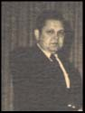

**Paul Halopoff**

1973-1974

President: Paul M. Halopoff

Vice Presidents: Bob Schram, Charles

Hempenstall, Fred Warren

Treasurer and Vice President: Roy L. Crawford

Executive Secretary: Mary Karp

Directors: Neil Rogers, Tony Font, Lowell Robinson, Mark Schanbacher, Don Sojka, Bob Miller, Herby Teichman, Ray Taylor, and Dave Burton



**Paul Halopoff**

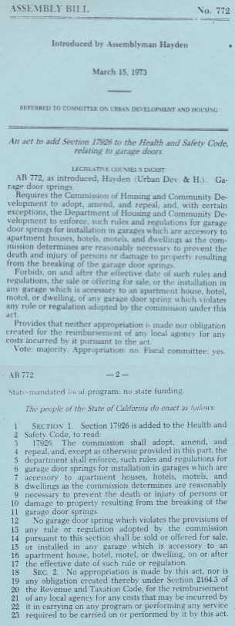

Beginning this year, non-member exhibitors were permitted to participate in the annual convention, and Dave Yoho was invited to be the primary speaker.

This was the year Assembly Bill 772 (an Act to add Section 17926 to the Health and Safety Code, relating to garage doors) was introduced. The Legislative Committee was assigned the responsibility of monitoring the bill.

In this year, Roy Crawford retired from the

Board after providing years of service.

1974-1975



President: Robert G. Schram

Vice President: Mark Schanbacher

Treasurer: Robert Miller

Executive Secretary: Mary Karp

Directors: Herby Teichman, Don Sojka, Dave Burton, Gene Scott, Robert Martinez, Paul Halopoff, Sandy McCormick, and Robert Smith

During this year, several new Committees were established:

News Bulletin Committee

Convention Committee

Golf Committee

Exhibitor & Membership Committee

Program & Publicity Committee

For those who did not play golf, the associa- tion provided an alternative…a fishing trip!

The Safety Committee reported Assembly Bill

722 passed by the House, and further hear- ings were held in Sacramento and Santa Ana. The FWGDA worked closely with Sacramento officials.

Ray Williams took the floor during the annual meeting, and stated that he and others felt that the FWGDA should have a “Western” president. He made it very clear that this conviction had absolutely no negative reflection on President Schram. Mr. Williams nominated Paul Halopoff for president.

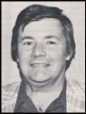

**Robert Schram**

1975-1976



President: Mark Schanbacher

Vice Presidents: Dave Burton and Robert

Martinez

Secretary/Treasurer: Robert Miller Executive Secretary: Dianne Anderson Directors: Ray Taylor, Dave Burton, Carl Hench, Stanley E. “Gene” Scott, A. W. “Sandy” McCormick, Robert Smith, R. L. “Bud” Harris, and Steve DeWitt

The 1975 annual meeting began with the following statement by Bob Martinez: “It has been regretfully drawn to my attention that per Section 7, Article II of the Bylaws of the corporation, that the purported meeting held in San Diego, California on or about March

15, 1975, was invalid due to the fact that a quorum was not present since not enough members were present at the meeting who were entitled to cast a majority vote. There- fore, any action taken at this meeting was invalid. Therefore, the officers and directors at that meeting were not duly elected. I make the motion that we adjourn this purported meeting, and have the de facto Chairman call his meeting to order.” This motion was with- drawn.

President Halopoff requested that a ‘vote of confidence’ be taken according to a letter he submitted to the Board of Directors. After the vote ‘vote of confidence’ was taken, Presi- dent Halopoff stated that he would resign due to the fact that the vote did not carry. A motion was then made to appoint Mark Schanbacher as the new president. The motion carried.

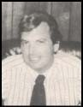

**Mark Schanbacher**

Mr. Halopoff informed the membership that the California Department of Housing and Com- munity Development had enacted a Code that called for garage door springs to have a mini- mum life of 9,000 cycles, and to have proper spring containment. The law became effective August 27, 1975.

President Schanbacher established the following committees:

Convention Committee

Membership Committee

Man of the Year Award Committee

Publicity Award

Technical Committee

Jerry Kenaga notified the Board that Assem- bly Bill 438 of Section 7090 had gone into effect on January 1, 1975. The law stated that if any contractor was caught doing a job with a building permit, there would be auto- matic penalties and immediate revoking or suspension of the license.

Several amendments were made to the association’s bylaws including:

Officers to be selected and approved by the Board

Term for any office was changed from

one to two years

1976-1977



President: Mark Schanbacher

Vice Presidents: Robert Martinez, S E Gene

Scott

Sec/Treasurer: A W Sandy McCormick Executive Director: Dianne Anderson Directors: Carl Hench, Robert Martinez, Robert Smith, L R Bud Harris, Steve DeWitt, L Brian McBride, Jim Harlan, Jim Yeager

The very first Membership Directory was published, and advertising was made avail- able in the newsletter. A full-page advertise- ment was $300.

Mr. Ted Farrell advised the organization that new FCC proposed regulations would require restricting frequencies allocated to garage door radio controls to three frequency bands, and change methods of measurement from average peak that would drastically reduce effective range.

A Group Health Insurance Plan by Pacific

Mutual was proposed.



**Mark Schanbacher**

1977-1978



President: Mark Schanbacher

Vice Presidents: Robert Martinez, S E Gene

Scott

Sec/Treasurer: A W Sandy McCormick Executive Director: Dianne Anderson Directors: Robert Smith, James Harlan, William Kenaga, Jack Nelson, L R Bud Harris, Steve DeWitt, Ron Radelet, L Brian McBride, Jim Yeager

The National Association of Garage Door Manufacturers (NAGDM) was in the process of writing a draft on one-piece door standards.

The FWGDA joined the Council of Industrial Business Associates. The group deals with product liability requirements, modifications, and laws enacted.

The medical plan proposed in 1977 was not implemented due to the lack of qualifying companies. Another company presented an alternative, dividend-producing program.

Holmes-Hally produced a one-minute film regarding spring containment, and safety that was distributed to California television sta- tions. The FWGDA decided to sponsor the film and have it distributed to Public Service Stations.

The concept of conducting Regional Meet- ings was brought up.

The California Crime Prevention Officers Association was working on a State Model Building Security Ordinance with the Attorney General’s Office. The code included garage doors.



**Mark Schanbacher**

1978-1979



President: Steve DeWitt

Vice Presidents: L R Bud Harris, Sandy

McCormick

Sec/Treasurer: Gene Scott

Executive Director: Dianne Anderson Directors: James Harlan, L Brian McBride, James Yeager, William Kenaga, Jack Nelson, Ron Radelet, Wes Day, Ed Freyder, Bill Whittaker, Jim Stiles

In this year, Mr. Gene Scott began a series of history articles for the newsletter. It was also decided to include workshops again during the annual convention; the two workshop topics were: Product Liability, and Installa- tion Techniques – Operators and Radio Controls.

Membership was at an all time high: 281 members. This was up 80% from 1976.

It was decided to include 24-hour security during the convention due to the increase in exhibitors and attendees. The convention featured 39 exhibitors and 911 attendees.

In January of 1979, the Board eliminated the Executive Secretary position, and reassigned the work to the directors. Ms. Diane Ander- son was recognized for her exceptional service to the association.

President Steve DeWitt presented a “Spring Replacement Chart” that was then distributed in the association’s newsletter.

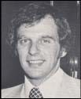

**Steve DeWitt**

1979-1980



President: Steve DeWitt

Vice Presidents: L R Bud Harris, Sandy

McCormick, James Yeager Secretary: L Brian McBride Treasurer: S E Gene Scott

Directors: Bill Kenaga, Jack Nelson, Ron Radelet, Wes Day, James Stiles, WM Eichenberger, Al Rankin, Ed Freyder, Bill Whittaker, Al W Marko, Dan Anderson

The newsletter took on a new format and included the following topics:

Pricing Forecasts

Future Convention Sites

Membership Polling and Feedback

News from other garage door trade associations

President’s Message

Ladies Auxiliary Message

Technical Message

Market Conditions

Accounting Practices

The membership was 342.

Various business forms were developed by Board members and distributed to the mem- bership for use in their everyday business.

Workshops for the convention included: Springing, Commercial Installation, and a Round Table Discussion.

Mr. Ernest Becker, Sr., past chairman, Na- tional Home Builders Association was the guest speaker.



**Steve DeWitt**

1980-1981



President: L R Harris

Vice Presidents: Jack Nelson, Ron Radelet

Secretary: L Brian McBride

Treasurer: James Yeager

Directors: Wes Day, James Stiles, Al Rankin, A W Marko, Bill Eichenberger, Dan Anderson, Neil Rogers, S E Gene Scott, Gary Singley, Bill Mohler

A program was established whereby a per- son representing the states covered by the association reported to the Board on legisla- tive affairs.

It was reported that a new industry associa- tion, the “Rocky Mountain Door and Operator Association” was formed. The purpose of the RMDOA was to promote training, safety, and continuity in the door business in the Rocky Mountain area.

A new “Activities” Committee was formed to be responsible for the development and promotion of workshops and seminars within the garage door industry.

Membership had grown to 410.

Mr. David Martin expressed interest in a merger of the Door & Operator Dealers Association (DODA), and the Far Western Garage Door Association. It was reported that DODA President Jerry Reynolds had reported to Mr. Bud Harris that DODA was not interested in joining forces at this time.

DODA invited the FWGDA to participate in a workshop to be conducted in San Diego. Mr. Bud Harris represented FWGDA.

Workshops for the upcoming convention included: Residential Management and Installation, Commercial Warehouse Door Market, and “Spring That Door.”

The Board approved a monthly letter to members informing them of legislation, small business laws, codes, and positions.

1981-1982



President: L R Harris

Vice Presidents: Jack Nelson, Ron Radelet, Wes Day, L Brian McBride

Secretary: Dan Anderson

Treasurer: James Yeager

Directors: Bill Eichenberger, Al Rankin, Neil Rogers, S E Gene Scott, Gary Singley, A W Marko, Bill Mohler, John Caruso, Jim Stiles

The Technical Committee, under the direc- tion of Chairman Bill Eichenberger, was working on a cable drums technical manual. The manual was not produced by the asso- ciation due to liability issues.

Mr. Carl Hinch, Advanced Overhead Door, reported that the State Board of Equalization for California had determined that radio control transmitter should be taxed as tan- gible personal property. Mr. Jack Nelson drafted a letter to the State Board regarding the association’s position on an improper tax.

It was decided by the Board that during convention exhibit periods other functions would not be scheduled. Workshops in- cluded: Installation, and FCC Requirements for operators.

Membership was made available to all states and countries.

1982-1983



President: Jack Nelson

Vice Presidents: Ron Radelet, L Brian

McBride, Wes Day Secretary: Dan Anderson Treasurer: Bill Eichenberger

Directors: Neil Rogers, S E Gene Scott, Gary Singley, Al W Marko, James Stiles,

John Caruso, Billl Mohler, Bill Lawrence, Ken

Roehl

It was decided to produce a paralegal guide to inform businesses of what they should or should not tell their customers.

The FWGDA joined with DODA, and the Door Operator and Remote Controls Manu- facturers Association in educating the public concerning garage door products.

The membership climbed to 462.

The Technical Committee worked on a report concerning insulation values and standards.

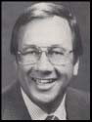

**Jack Nelson**

1983-1984



President: Jack Nelson

Vice Presidents: Ron Radelet, Dan Ander- son

Secretary: James Stiles

Treasurer: Bill Eichenberger

Directors: John Caruso, Al W Marko, James Felger, Bill Lawrence, Bill Mohler, Ken Roehl, David P Haslam, Carl Hench, Jeff Davis,

Gary Rosenberger, Brian Besser

It was reported that the California Dealers had won their case regarding the taxation of additional transmitter sales.

The first Regional Meeting was held on September 28, 1983 in Sacramento as a test. The meeting was successful with 56 people attending. Other Regional Meetings were then scheduled for Seattle and the Bay area.

This marked the 20th anniversary of the association’s annual convention.

It was reported that DODA’s convention in Cincinnati had 73 exhibitors and 1,327 in attendance.

Mr. Ron Radelet reported that the Glenn

Berry Garage Door Historical Foundation had been formed to collect and preserve artifacts relating to the industry. Mr. Glenn Berry was named to be responsible for the Foundation with the assistance of Mr. Roy Crawford.



**Jack Nelson**

1984-1985



President: Bill Mohler

Vice Presidents: James Stiles, John Caruso

Secretary: Bill Lawrence

Treasurer: Ken Roehl

Directors: Brian Besser, Jeff Davis, James Yeager, David Haslam, Carl Hench, Gary Rosenberger, James Fegler, Pat Kelly, Virgil Smith

Mr. Ray Sobel, Linear Corporation reported that the FCC had changed how radio power was to be measured, consequently narrowing the wave length that reduces radio power output. DORCMA will fight the ruling as long as possible.

The association adopted an Honorary Mem- bership category with the first Honorary Members being:

Mr. John Paul Mr. Jack Rains Mr. Ray Williams

Some new articles featured in the newsletter were: Extension and Torsion Spring Charts, and Sectional Panel Comparison Chart.

Membership was reported to be 469.

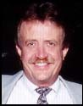

**Bill Mohler**

1985-1986



President: Bill Mohler

Vice Presidents: James Stiles, John Caruso

Secretary: Bill Lawrence

Treasurer: Ken Roehl

Directors: David Haslam, Carl Hench, Gary Rosenberger, James Fegler, Pat Kelly, Ted Thorell, Jeff Davis, Brian Besser, Virgil Smith, James Wilkes

The Board of Directors voted to contract with The Messersmith Group to provide manage- ment services to the association. Dr. Lloyd E. Messersmith was appointed Executive Director.

The Board investigated producing safety stickers for doors and springs.

The Salt Lake City Regional meeting was conducted (4th Annual). A total of 74 people attended, and Chuck Coonradt was the featured speaker. Despite records for the earliest and most snowfall in Denver, on September 28, 1985, the FWGDA Regional witnessed 57 brave souls attend the meeting. Speakers included David Begley, Leeson Electric Company, Jim Bender, Robinson- Bender & Associates, and Frank Alsonso, Halco Spring & Manufacturing Company.



**Bill Mohler**

1986-1987



President: Bill Lawrence

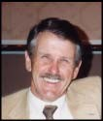

Vice Presidents: Ken Roehl, David Haslam

Secretary: Pat Kelly

Treasurer: Gary Rosenberger

Directors: James Fegler, James Wilkes, Harry Hughes, Brian Besser, Jeff Davis, Ted Thorell, Walt Evans, Phil Patton, Jim Shea

The association joined with the Sierra Credit Union to introduce a new benefit to the mem- bership. The membership totaled 504.

Theme for the 1987 Convention was “Magic.” FWGDA decided to support the American

Rolling Door Institute for periodic testing of

installed fire door assemblies. In addition, the association produced torsion spring identification and order forms.

A Committee was formed to study telephone book classifications. The objective of the study was to consolidate to one title or classi- fication.

The Annual Convention attendance was recorded to be 2,007.

**Bill Lawrence**

1987-1988



President: Bill Lawrence



Vice Presidents: Ken Roehl, David Haslam

Secretary: Pat Kelly

Treasurer: Gary Rosenberger

Directors: Brian Besser, Jeff Davis, Ted Thorell, Walt Evans, Phil Patton, Jim Shea, Harry Hughes, James Wilkes, Bill Walker

The Steering Committee worked on an Affili- ate membership category to the bylaws.

The American Rolling Door Institute con- ducted an industry meeting concerning fire doors. ARDI proposed establishing a Steer- ing Committee comprised of industry repre- sentatives from ARDI, FWGDA, and DODA, plus representatives of UL, NFPA, Building Code Officials, Fire Chief Associations, and other interested parties. Three sub-commit- tees were proposed: 1) Training, 2) Codes, and 3) Public Relations.

FWGDA provided support to the California Operator and Door Association regarding proposed standards to the State of California Building Code for garage doorjambs:

Type of Wood to be Douglas Fir Only, Grade to be Standard or better, and minimum thick- ness to be 1 ½” finished thickness and dry.

**Bill Lawrence**

1988-1989



President: Ken Roehl

Vice Presidents: David Haslam, Ted Thorell

Secretary: Gary Rosenberger

Treasurer: Jim Shea

Directors: Walt Evans, Phil Patton, Harry Hughes, Bill Walker, James Wilkes, Russell Dunn, Donald Harrison, James Yeager, Ray E Zarodney, Robert Cookson

Legislative Chairman Bill Walker updated members regarding California legislation addressing primary contractor retention. A hearing was to be held on October 28, 1988. It was reported that a compromise bill would be introduced in the 1989 legislative session.

It was reported that ARDI had established a Public Relations Committee, a Program Committee, and a Codes Committee for fire door testing. The Codes Committee ex- pected to have annual fire door testing lan- guage in the Code by the conclusion of 1988.

This year marked the 25th Anniversary of the

FWGDA Convention.

It was reported that FODA was sponsoring a training and certification program for install- ers. The organization was certifying install- ers who participated in the curriculum and successfully completed tests.

The association discussed the pros and cons of joining with DODA to conduct seminars and/or conventions. No action was taken.

FWGDA reintroduced a business insurance program through Sacramento Valley Insur- ance.

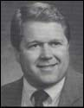

**Ken Roehl**

During the annual meeting, a proposal to change the association’s name to “American Door Association” failed for lack of support.

The Garage Door Association of Arizona was organized and supported by FWGDA.

A “Red Tag” program was being considered by the Board due to recent fatalities of chil- dren allegedly involved in garage door- related accidents.

1989-1990



President: Ken Roehl

Vice Presidents: David Haslam, Ted Thorell

Secretary: Gary Rosenberger

Treasurer: Jim Shea

Directors: Harry Hughes, Bill Walker, James Wilkes, Russell Dunn, Donald Harrison, James Yeager, Ray Zarodney, Robert Cookson, David Presba, Loren Vickers

This year marked the first four-color edition of *Far Western News.* An Education Com- mittee was formed, and a five-year plan complete with mission statement was adopted.

Discussions were pertaining to the possible creation of a prevailing wage for garage door installers.

NAGDM proposed forming an advisory group consisting of FWGDA, NAGDM, DODA, ARDI, and DORCMA. The proposed advi- sory group would work together on training, and various industry standards. FWGDA decided to move forward with participation in the advisory group. The organization formed was called the “Organization of Door and Operator Industry Associations.” The organization’s mission was:

*“To provide a forum for the liaison among legally organized, door and operator industry trade associations, and to establish cooperation and understanding in regard to industry related issues and projects.”*



**Ken Roehl**

DODA proposed a garage door industry exposition co-sponsored by the FWGDA and DODA for 1993. It was decided to conduct this event in Las Vegas, Nevada.

During the annual meeting of members, DORCMA representative Ray Sobel presented information on safety issues relative to garage door and opener systems as a result of a new Minnesota law requiring all garage door open- ers to meet UL requirements by January 1991, and to meet additional safety requirements related to the door’s reversing system by 1993.

1990-1991



President: Jim Shea

Vice Presidents: Robert Cookson, James

Yeager

Secretary: Ray Zarodney

Treasurer: Donald Harrison

Directors: Russell Dunn, David Presba, Loren Vickers, Jeff Davis, Walt Evans, Bill Walker, Brian Besser, Steven Harris, Vince Perdue, James Wilkes

During the year, the Board established a legislative program to be coordinated by the Messersmith Group. The program monitored legislation in the 11 western states as well as the District of Columbia.

A significant sectional door installation seminar was scheduled for the 1991 FWGDA conven- tion with a seminar budget of $10,000.

California AB 3600 requiring an additional safety reversing device on garage door open- ers was signed into law by Governor George Deukmejian on Wednesday, September 26,

1990 with the provisions to become effective

January 1, 1991.

*The* Far Westernews *was transformed into an association magazine.*

The association cooperated with the National Safety Council on a major garage door safety project underwritten by DORCMA.

The Consumer Product Safety Consumer Act of 1990 was signed by President Bush and became law effective January 1, 1991. The Act included the following provision:

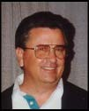

**Jim Shea**

“All automatic garage door openers (residen- tial) must conform to US 325 entrapment protection standards; must be labeled with the date of manufacture and the product’s compli- ance with the UL standard in effect; and manu- facturers, in cooperation with the CPSC, must work to educate the public on the entrapment dangers.”

The Act included an additional provision to go into effect January 1, 1993, “Requires that automatic garage door openers include an additional entrapment protection device (i.e. electric sensing edge, optical sensor or other equivalent non-contact sensor). The specific device is to be determined by UL in the form of a revision of UL 325.

FWGDA membership was reported to be 522.

1991-1992



President: Jim Shea

Vice Presidents: Robert Cookson, James

Yeager

Secretary: Ray Zarodney

Treasurer: Donald Harrison

Directors: David Presba, Loren Vickers, Jeff Davis, Walt Evans, Bill Walker, Brian Besser, Stephen Anderson, Russell Dunn, Vince Perdue, Mike Truman, Ray Etchepare

It was reported that the Organization of Door and Operator Industry Associations had started as an information-sharing group, and had evolved into a formal organization working for the good of the door and operator industry with the focus on safety. The organization’s role

with the National Safety Council was oversight of the “Garage Door Safety Campaign.”

Certificates of Completion were distributed to those who attended the Sectional Door Installa- tion Program conducted during the annual convention.

It was acknowledged that FWGDA had taken a lead role in the legislative arena, and that the association was viewed as a credible force in the legislative process.

Membership was reported to be 547, and the annual convention featured 209 booths, 72 exhibiting companies, and 1,300 attendees.



**Jim Shea**

1992-1993



President: Robert Cookson

Vice Presidents: Bill Walker, Vince Perdue

Secretary: Donald Harrison

Treasurer: Walt Evans

Directors: Ray Etchepare, Timothy Kolhoff, Jeffrey Murphy, Russell Dunn, James Redman, Greg Riddle, Mike Truman, Ralph Dalia, Timothy Mulholland, Greg Schults

The Board decided to establish liaison rela- tionships with local and state industry trade organizations.

A Member Services Committee was created. The association dealt primarily with legislative issues during the year including:

Model Garage Door Opener Legislation

Americans with Disabilities Act

UL 325 Safety Standards

Consumer Product Safety Commission

Contractor/Subcontractor Issues

Illness and Injury Prevention Program

Workers Compensation Insurance

Reform

The Board considered producing the maga- zine six times rather than four. It was ultimately decided to retain the four-issue frequency.

A major membership drive was initiated and the magazine was mailed to 2,000 prospective dealers. Incentives were provided to members for recruitment efforts.

The association established a Task Force to move forward with development of a Chapter program.

A Task Force was appointed to represent the FWGDA in discussions with DODA with a focus of answer the question, “What is in the best interest of the door dealer?”

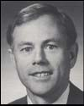

**Robert Cookson**

1993-1994



President: Robert Cookson

Vice Presidents: Bill Walker, Vince Perdue

Secretary: Donald Harrison

Treasurer: Walt Evans

Directors: Ray Etchepare, Timothy Kolhoff, Joyce Kenaga, Russell Dunn, Jerry Trask, Sr., Greg Riddle, Mike Truman, Ralph Dalia, Timothy Mulholland, Greg Schults, Dwight Hodges

It was reported that NGDMA may change its name to include all industry manufacturers.

With the formation of the Garage Door Industry Task Force (FWGDA and DODA representa- tives), discussions took place regarding the advantages and disadvantages of blending the two organizations into one.

Several issues were discussed about the consolidation/merging of the two organizations:



**Robert Cookson**

It was agreed to continue working with DODA on the development of a national legislative monitoring program for the industry (the pro- gram to also include NAGDM and DORCMA).

A FWGDA/DODA merger agreement was proposed and accepted. The merger would become effective January 1, 1996.

The creation of an Industry Education Founda- tion with involvement from all industry organiza- tions (FWGDA, DODA, NAGDM, DORCMA,

|  |  |  |
| --- | --- | --- |
| · | The development or creation of national | and ARDI) was being discussed. The plan |
|  | industry association | was to have the educational institute opera- |
| · | The importance of retaining the history | tional by January 1, 1996. |
|  | of both organizations |  |
| · | The need for careful consideration to | *I*t was reported that the insurance program |
|  | the merger, and the need to review the | provided by C.N.A. Insurance (endorsed by |
|  | timeline | DODA) was to be provided to the FWGDA |
| · | The acknowledgement that a merger | dealer members as a member service. |
|  | should be a strength to the industry, and |  |
|  | a service to the involved memberships |  |
| · | The importance of communicating the |  |
|  | merger concept to the general member- |  |
|  | ships in a positive, informed manner |  |

The Board of Directors approved the consoli- dation recommendations of the Garage Door Industry Task Force on July 10, 1993. It was also agreed to conduct the 1995 Convention in conjunction with DODA in New Orleans.

1994-1995



President: Bill Walker

Vice Presidents: Donald Harrison, Timothy

Mulholland

Secretary: Mike Truman

Treasurer: Joyce Kenaga

Directors: Walt Evans, Dwight Hodges, Greg

Schults, Wade Bennett, Ray Etchepare, Anna Jung, Garry Stewart, Bill Lawrence, Flossie Miller, Jerry Trask, Sr., Ed White, Tim Kolhoff

It was decided that FWGDA and DODA would continue publishing their own respective publi- cations until the publication of the International Door Association (IDA) could be established.

During the July Board meeting, it was reported that the International Door Association had its first meeting in June. The FWGDA transferred

$34,000.00 from its general account for admin- istrative expenses of the IDA.

A “Wall of Fame” was developed as part of the

Expo ’95 activities.

Don Harrison, Education Committee Chairman reported that the Institute of Door Dealer Education and Accreditation (IDEA) meeting had been conducted in Chicago. Corporate papers for the foundation had been filed with the Institute’s primary purpose being a certifi- cation program.

The FWGDA endorsed the concept of a High Roller Club to help increase membership for IDA.

It was reported by the IDA Selection Commit- tee that Smith, Bucklin & Associates, Chicago, Illinois had been retained to manage the IDA.

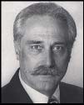

**Bill Walker**

The International Garage Door Expo theme for

1996 was selected to be: “United for Excel- lence.”

The year of 1995 (after Expo) consisted of only six months due to the creation of the Interna- tional Door Association. Extensive prepara- tions were made due to the merger.

It was reported that the IDEA Board would consist of 6 dealer and 6 manufacturer repre- sentatives. It was also reported that the ele- ments of the proposed accreditation program had been presented to NAGDM representa- tives.

*The final Board meeting of the Far Western Garage Door Association was conducted on November, 3, 1995.*

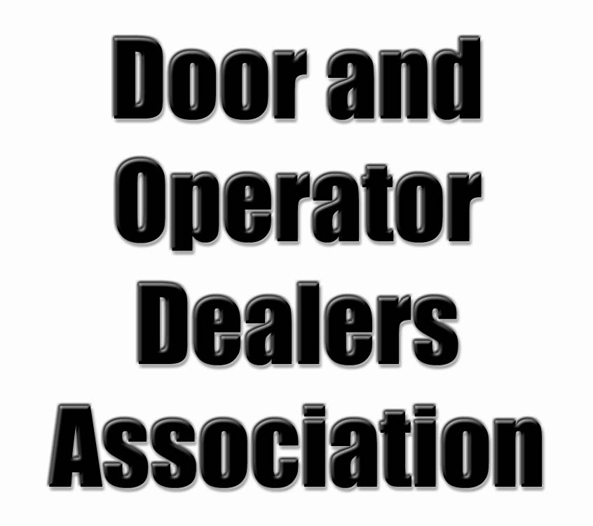

Heritage of the International Door Association 35

1973

President: Louis E Stepanik

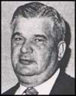

Vice Presidents: Albert L Heller, Raymond L Crampton

Secretary/Treasurer: Tony A Font Directors: Joseph Arcadi, Joseph Caputo, Eugene Chesko, Thomas Degata, Kenneth Haas, Gary Kalister

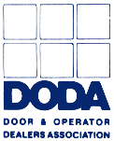

Co-Chairman of the Workshop Committee, and Editor of DODA NEWS was Tony A. Font.

The business outlook for the year was tight money, climbing interest rates, and a slow- down of new construction.

A prediction from the year, “The Consumer Product Safety Commission’s impact on business in the USA, and overseas will be greater than that of any Federal regulatory agency ever created by Congress.

On September 26, what was billed as “the first workshop of its type, ever presented to the door and operator industry” was held at the Imperial House North with 393 attendees representing 161 firms. The program in- cluded 19 panelists, and featured sales motivator, Dave Yoho.

**Louis E Stepanik**

1974

President: Joseph A Caputo



Vice Presidents: Donald H LaHote, James F Sievers

Secretary/Treasurer: Tony A Font

Imm Past President: Louis E Stepanik

Sgt-at-Arms: Tony M Rosso

Directors: Raymond L Crampton, Eugene J Chesko, Wayne E Harroun, Gary B Kalister, Chet McKee, Donald Craig, Everett P Barker

The 1st Annual Convention & Exposition was conducted in Chicago, Illinois. The event drew 568 attendees, and 27 exhibitors. The association’s new group insurance plan, SAFETY-PAC was unveiled during the con- vention.

The Nominating Committee submitted a slate of candidates to the Board for election by the General Membership. The Board was to be composed of 13 directors.

During the year, a Code of Ethics was adopted.

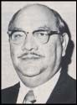

**Joseph A Caputo**

1975



President: Anthony M Rosso Vice Presidents: Secretary/Treasurer: Tony A Font Directors:

The industry sales were stated to be $250 million.

The 2nd Annual Convention & Exposition was conducted in Rosemont, Illinois, August 20-

22. Registrations were received from dealers in 28 dates and Canada.

Effective with the October/November issue of DODA NEWS, classified and display adver- tisements were made available.

The Board voted to publish DODA NEWS bi- monthly with a goal of printing a minimum of

24 pages in each issue. A further direction was to have at least 50% of the publication

be devoted to editorial content as opposed to advertising.

Atlanta was chosen as the site for the 1976

Convention.

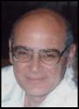

**Anthony M Rosso**

1976

President: Larry Donlin



Vice Presidents: Joe Caputo, Dan Hinkes

Secretary/Treasurer: Tony A Font Imm Past President: Tony M Rosso Sgt-at-Arms: Bud Whittemore

Directors: Tom Cordonnier, Jim Fawcett, Dick Kasnick, Don Lahote, Paul Marsted, Gerald Scott, Bob Strafford, Frank Vaughan

This was the Bicentennial Year for the United

States.

DODA NEWS was being mailed to 3,500 firms and individuals.

Dennis Schlabach received the George M. Ayers Sales Award from Mr. Ayers, himself, at the company’s annual sales meeting.

The 3rd Annual Convention was conducted at the Atlanta Hilton, Atlanta, Georgia, and the theme was “All Roads Lead to Atlanta.” The event attracted guests from overseas.

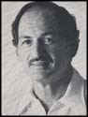

**Larry Donlin**

1977

President: Bud Whittemore

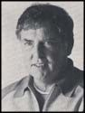

Vice Presidents: Paul Marsted, Joe Caputo

Secretary/Treasurer: Tony A Font

Directors: Larry A Donlin Charles Bucheridge, Tom Cordonnier, Ron Nix, Bill Eichenberger, Don LaHore, Bob Schram, Gerry Scott, Bob Strafford, Jack Trout



The 4th Annual Convention was conducted in

Dearborn, Michigan, July 27-30.

The association’s Board established a Long

Range Planning Committee.

The association introduced service decals, and updated its Membership Directory.

A 5th series of educational workshops was presented in Kansas City, Missouri on Febru- ary 18.

The Board undertook a project of gathering and disseminating information covering all facets of the industry via the DODA MANUAL.

Office facilities were acquired for DODA in

Strongsville, Ohio.

The first national standard for sectional doors was approved by the American National Stan- dards Institute (ANSI A216-1). The standard covered residential, commercial, and industrial vehicle doors.

**Bud Whittemore**

1978

President: Joseph A Caputo

Vice Presidents: Ron Nix, Paul Marsted

Secretary/Treasurer: Tony A Font

Imm Past President: Bud Whittemore Directors: Charles Buckeridge, Ed Edwards, Stan Ellis, Bill Eichenberger, George Folk, Carlos Ramos, Jack Trout, Bob Schram, Bob Strafford, Bill Whitaker, John Zoller



**Joseph A Caputo**



Dealers enjoyed another banner year, and several new committees were formed including a Long Range Planning Committee.

During the year the membership took a healthy increase, and the annual convention was the largest to date. The convention was conducted at the Opryland Hotel in Nashville, Tennessee, and featured speaker, Dave Yoho. The con- vention attendance was 841 with 45 exhibits. The convention banquet was enjoyed by 517 people.

The DODA Board celebrated the final move into the association’s new headquarter offices in Strongsville, Ohio

During the year, the Door & Operator Dealers Association of Wisconsin, and St. Louis be- came the second and third regional associa- tions to join DODA as Affiliate Associations.

It is interesting to note that in 1978, the aver- age pay for an experienced salesman was

$20,440.

1979

President: Ron Nix

Vice Presidents: Jerry Reynolds, Carlos

Ramos

Secretary/Treasurer: Tony A Font

Imm Past Pres: Joe Caputo

Directors: Ray Blakenheim, Russ Dunn, Ed Edwards, Stan Ellis, George Folk, Charles Lines, Paul Marsted, Bill Murakami, John

Skipton, Bill Whitaker, John Zoller **Ron Nix**

In this year, President Jimmy Carter described to the American people his program for com- bating inflation, the country’s most pressing economic problem.



DODA and its Wisconsin Affiliate conducted at meeting at the Red Carpet Hotel in Milwaukee. The event attracted 173 dealers, distributors and manufacturers.

It was reported that the National Association of Garage Door Manufacturers (NAGDM) had 39 members.

DODA introduced the DODA Manual that included helpful information for dealers.

The 6th Annual DODA Convention was con- ducted at the McCormick Inn in Chicago, July

18-20.

The association conducted an Operational Review Survey and more than 100 participa- tion cards were returned to the DODA office.

The association’s membership was 315 with

19 of them being international. It was expected that the association would reach 500 members by late 1979 or early 1980.

During a meeting of the Board on April 19, the association purchased a word-processing, mini-computer system. It was a major mile- stone that resulted from a three-month study of need, feasibility and equipment.

A special meeting celebrating the 20th anniver- sary of the Door Operator and Remote Con- trols Manufacturers Association was con- ducted at the Hilton O’Hare in Chicago.

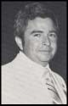

An interesting note from the year: the federal government was spending $15,000 a second.

1980

President: Jerry Reynolds



Vice Presidents: John Skipton, Russ Dunn

Secretary/Treasurer: Tony A Font

Imm Past Pres: Ron Nix

Directors: Ray Blankenheim, Joe Caputo, Jack Ginther, Don LaHote, Charles Lines, Dave Martin, Bill Murakami, Ralph Nordick, Bob Vogel, John Zoller, Harold Tonnessen

New membership during the year reflected a healthy 45% increase, and the Convention drew record numbers. The membership total was 453 firms on May 8. Attendance at the convention was 875 people with 81 booths.

The association’s publication, DODA NEWS maintained its gradual expansion and refine- ment during the year.

The association entered the audio-visual age with the introduction of a training program

using the LaBelle Cassette Projection System. The training program initially included cassette training films on Overhead Door Hardware Technology, and was previewed during

DODA’s Northeast Regional Workshop in

Philadelphia on October 23.

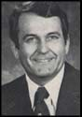

**Jerry Reynolds**

1981

President: Jerry Reynolds



Vice Presidents: Lamont Benedict, Ralph

Nordick, Bill Marko

Secretary/Treasurer: Tony A Font

Directors: Frank Bailey, Keith Bomholt, Joe Caputo, Don Corzett, Jack Ginther, Tancil Horne, Don LaHote, Ed Oberhaus, Bob Vogel, Harold Tonnessen, John Zoller

The Regional Workshops continued to be highly successful, and the 8th Annual Conven- tion was conducted in New Orleans, August 2-

6. The Convention featured 79 of the leading industry manufacturers and encompassed 108 booths. This compared to 58 exhibitors and

81 booths the previous year in St. Louis.

DODA conducted its 13th Regional Workshop in San Diego, California. This was the first time the DODA had presented workshops on the west coast, and it was a big success.

By an overwhelming vote of 207 to 30, the voting membership approved an amendment to the bylaws that eliminated the membership classification of Affiliate Associations.

The LaBelle Dual 16 projector brochure and program listing was unveiled, and made avail- able to the entire membership.



**Jerry Reynolds**

1982



President: Tancil Horne

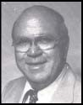

Vice Presidents: Lamont Benedict, Mike

Cordes

Secretary/Treasurer: Tony A Font

Imm Past Pres: Jerry Reynolds

Directors: Keith Bomholt, Chris Caputo, Don Corzett, Bill Fagan, Jack Ginther, Bill Marko, Ed Oberhaus, Larry Pahlow, Jack Pierce,

Dennis Schlabach, Dick Zumwalt **Tancil Horne**

The association’s fiscal year was changed from July 1st to January 1st.

A customized DODA service decal remained to be the association’s best group purchase program.

Seven DODA training programs were now on cartridge for the LaBelle Audio-visual pro- grams.

A new organization, the Garage Door & Op- erator Association was formed in New York.

The 1982 convention set new records with

1,054 attendees representing 313 firms, and a new record of 81 exhibitors and 110 booths.

A new organization, the Garage Door Council was formed by the industry associations to provide public information.

1983

President: Tancil Horne



Vice Presidents: Mike Cordes, Dick Zumwalt, Bill Fagan

Secretary/Treasurer: Tony A Font

Directors: Chris Caputo, Jack Ginther, Larry Pahlow, Dennis Schlabach, Stella Sayles, John Carl Jr., Bob Schram, Tom Cordonnier, Jim Cookson, Jerry Trupiano

In January, the Board voted to revise the Op- erational Review Survey (ORS), and replace it with the Development of Dealer Accounting and Financial Improvement Techniques pro- gram (DODA-FIT).

It was reported that the film lab used to pro- duce LaBelle audio-video cassettes had been replaced due to unsatisfactory cassette pro- duction.

The 10th Annual Convention was booked in Cincinnati, Ohio on June 12-15, at the Stouffer’s Hotel.

The Garage Door Council announced its activities after one year of operation. The Garage Door Council produced a pamphlet on garage door maintenance and safety.

The production of the association’s magazine was contracted with Bell Publicom, Dayton, Ohio. The name of the publication was changed from *DODA NEWS* to *INTERNA- TIONAL DOOR & OPERATOR INDUSTRY.* The magazine’s content and basic format were expanded to better reflect the industry and association’s growth.



**Tancil Horne**

The first issue of *International Door & Opera-*

*tor Industry* was dedicated to Tony Font in recognition of his outstanding leadership and dedicated service to the industry. He was a founder and leader of the Door & Operator Dealers of America for 11 years. Mr. Font was featured on the cover of the magazine.

The 1984 Convention was scheduled at the

Atlanta Hilton, July 22-26.

Before the conclusion of 1983, the association contracted with Bell Publicom, Dayton, Ohio to provide total management services, and named Chris Long as its Managing Director.

1984

President: Bill Fagan

Vice Presidents: Chris Caputo, Stella Sayles

Treasurer: Jack Pierce

Imm Past Pres: Tancil Horne

Directors: John Carl Jr., Jerry Reynolds, Jim Tull, Jack Adams, John McKee II, Jack Ginther, Bob Schram, Tom Cordonnier, Jim Cookson, Jerry Trupiano

Managing Director: Chris Long **Bill Fagan**



The Board of Directors met in Dayton, Ohio in December 1983, and approved an operating budget exceeding $400,000. An emphasis was placed on increasing membership ser- vices. The Board authorized expenditures for the establishment of a committee to study the development and implementation of a strategic plan for the association.

The 1985 Convention was scheduled for

Orlando, Florida, July 21-25.

The first issue of *International Door & Opera- tor Industry* was critiqued and received posi- tive response. Don Mounce was introduced as the magazine’s new editor. Mr. Mounce re- placed former editor, John Stratton.

The Board voted to make the Membership Directory available to non-members at a cost of $25.00.

The DODA Board voted to approve a new logo,

During 1984, Tony Font died during the transi- tion to Bell PubliCom. The president of Bell PubliCom, Jerry Bell, and magazine editor, John Stratton were killed in an air accident. The Board chose to proceed with C. S. Long, Inc., (later changed to Long & Associates, Inc.) and Chris Long as its Managing Director.

The Strategic Planning Committee chaired by Jim Cookson met on September 26, 1984. The committee drafted a formal mission state- ment and adopted seven general goals. The

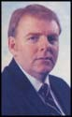

Mission Statement read, “To establish the Door

& Operator Dealers of America as the major trade association in the door and operator industry.”

1985

President: Bill Fagan

Vice Presidents: Jim Tull, Stella Sayles

Treasurer: Jack Pierce

Pres Elect: Jerry Reynolds

Directors: Chris Caputo, Jack Adams, John McKee II, Jack Ginther, Jerry Trupiano, Jim Cookson, Ken Monnin, Gordon Churchward, Bob Cahill, John Zoller

Managing Director: Chris Long **Bill Fagan**

The association’s name was changed on December 1, 1984 to Door & Operator Deal- ers Association (DODA). The new name reflected the association’s aggressive move to dramatically expand member service pro- grams and membership.



The 1985 budget and plan called for growth and continuous improvement of the association’s annual conventions. The 1985

Convention was conducted in Orlando, Florida July 6-9. The convention theme was very fitting to DODA’s 1985 mission – *United We Stand.*

The association scheduled two regional edu- cational conferences; one in San Antonio and the other in Denver.

The San Antonio Conference was a huge success with more than 300 industry represen- tatives attending the two-day event (February

1-2).

The President’s editorial by Bill Fagan empha- sized the fact that “DODA isn’t just comprised of people; it is people.” He stated, “The two key elements of DODA are dedicated volun- teers and service. I personally like to refer to DODA as the people-oriented association. Its sole purpose is to serve the needs of its mem- bership.”

1985 was an excellent year for DODA. The association grew in membership, conducted its most successful convention to-date, intro- duced several new programs, and improved some existing ones.

The magazine included an article on one of its members, Ed Niit – A True American Success Story. Mr. Niit was the 1985 recipient of the Joe Caputo Dealer of the Year Award.



The association’s Computers Users Group introduced the first computer software program designed specifically for door dealers.

1986



President: Jerry Reynolds



Vice Presidents: Jim Tull, Ken Monnin

Treasurer: Jack Pierce

Imm Past Pres: Bill Fagan

Directors: Chris Caputo, Jack Adams, John McKee II, Stella Sayles, Jack Ginther, Jerry Trupiano, Jim Cookson, Gordon Churchward, Bob Cahill, John Zoller

Managing Director: Chris Long **Jerry Reynolds**

The 13th DODA Convention was conducted in Indianapolis, Indiana, June 7-10. The conven- tion theme was *Race for Profits*, and the keynote speaker was Johnny Rutherford. The President’s banquet featured “The Lettermen.”

During the year the Computer Users Group continued its work, DODA sponsored a busi- ness insurance program via C.N.A. Insurance, and the association sponsored an advertising contest for door dealers.

The convention theme for 1987 was estab- lished to be “You Are the Key”, and the conven- tion was booked at the Opryland Hotel, March

12-15.

President Jerry Reynolds stressed the numer- ous programs of DODA, and his December editorial was titled, “Tis the Season to be Thankful.” In the article, he stated, “A sure way to eliminate the year-end blues is to take time to reflect upon the positive things that have happened.”

During the 1986 Convention, the association recognized Harold Tonnesen and Jim Weeks for 32 years of business by presenting them with the Joe Caputo Dealer of the Year award.

1987



President: Jerry Reynolds



Vice Presidents: Jim Tull, Ken Monnin

Treasurer: Jack Pierce

Pres Elect: John Carol Jr.

Directors: Cecil Williams, William Mathews, Bearge Miller, Stella Sayles, Jerry Trupiano,

Jim Cookson, Bob Cahill, Gordon Churchward, John Zoller

Managing Director: Chris Long **Jerry Reynolds**

The 14th Annual Convention was conducted in Nashville, March 12-15. Beginning with Nash- ville Convention it was decided to make a donation to a worth charity in the host city of the convention. The recommendation to do so came from past president Tancil Horne. During the convention, a check in the amount of

$5,000 was contributed to *Loaves and Fishes Community Meals.* The organization was responsible for feeding 25- people (adults and children) three times per week. The Board decided to name the annual award after Mr. Horne – Tancil A. Horne Charity Award. The Nashville Convention set an attendance record of 2,200 people.

DODA conducted a very successful Regional Conference in Dayton, Ohio at the business of Dayton Door Sales on October 1-2. The conference was attended by 300 industry representatives, and was hosted by Ken Monnin, president, Dayton Door Sales.

The 1988 Convention was set for Little Rock, Arkansas, May 7-10, and the theme was set to be “Quest for Quality.”

During the year, the American Rolling Door

Institute initiated a fire door testing program.

1988

President: John Carl Jr.



Vice Presidents: Ken Monnin, William F Mathews

Treasurer: Jack Pierce

Imm Past Pres: Jerry Reynolds

Directors: Richard J Miller, Cecil E Williams, Jim Tull, Bearge Miller, Stella Sayles, Jerry Trupiano, James R Yeager, Gordon Churchward, Bob Turcotte, John Zoller, Bob Markwart

Managing Director: Chris Long

In 1988 the annual convention changed its name to the International Garage Door Exposi- tion, and was conducted in Little Rock, Arkan- sas, May 7-10. The theme was “Quest for Quality”, and the President’s Awards Banquet featured Roy Clark.

A new tool for business communications was gaining popularity – Facsimile! It was esti- mated that every business would have one in the near future. Main advantage of the FAX was speed, low cost of transmission, and complete accuracy of material.

The first DODA Art Fair was conducted during the Exposition, and it was a big success. During the Expo, DODA acknowledged its

1,000th member, Lance Griffin, Overhead Door

Company of San Francisco.

The 1989 Convention was set for Cincinnati, Ohio, May 27-30, and the theme was set as “Doorway to the ‘90s”.

The Board of Directors voted unanimously to commission a study designed to identify the specific educational needs of door dealers.

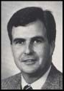

**John Carl Jr.**

The Joe Caputo Dealer of the Year Award was presented to William W. Graham, Delta Door Systems, Inc. Mr. Graham stated that he “is a firm believer in the fact that happiness is the one commodity that multiplies by dividing it.”

The largest Regional Conference ever pro- duced by DODA was held in King of Prussia, Pennsylvania on October 6-7. The Regional Conference was attended by 350 attendees, and 51 exhibitors.

1989

President: John Carl Jr.



Vice Presidents: Cecil Williams, Bill Mathews

Treasurer: Jack Pierce

Pres Elect: Ken Monnin

Directors: Jim Tull, Stella Sayles, Richard Miller, Jim Yeager, Dick Zumwalt, Bob Markwart, Bearge Miller, Bob Turcotte, Chip Cordes, Keith Glover

Managing Director: Chris Long

March 17, 1989 marked the first day of

HazCom enforcement.

In April, the Board received the results of the Industry Survey. Using the results, DODA’s Strategic Planning Committee, and Education Committee began plans to develop a five-year plan.

The *Product Reference Directory* was intro- duced in 1989.

During the 16th annual Exposition, President Carl summed it up as being “emotionally intensive.” DODA contributed $2,500 each to Boys Hope and the Bethany House. Three directors retired from service: Gordon Churchward, Jerry Trupiano, and John Zoller.

The 1989 Convention and Exposition created momentum for the association. During the year, several new training films were made available, and a DODA Safety Manual was produced.

The 1990 Exposition was scheduled for New Orleans, June 7-10. DODA decided to pro- duce an industry cookbook for distribution in the first quarter of 1990.



**John Carl Jr.**

1990

President: Ken Monnin

Vice Presidents: Cecil Williams, Stella Sayles

Treasurer: Jack Pierce

Directors: Jim Tull, Bill Mathews, Bill Winser, Bearge Miller, Bob Markwart, Bob Turcotte, Jim Yeager, Connie Breedlove, Doug Kidd, Dick Zumwalt, Keith Glover

Managing Director: Chris Long

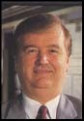

**Ken Monnin**

Theme for the 1990 Exposition was “Opening



to a New Decade”. The primary purpose of the association was to help educate dealers in the areas of business management, technical training, and industry-wide educational needs.

The 1990 Exposition was held in New Orleans, June 7-10. Helen Reddy performed at the President’s Banquet where more than 1,000 people attended. Attendance exceeded 2,000 for the Expo, and $5,000 was donated to the Metropolitan Battered Women’s Program.

A training film covering the installation of a residential operator was completed.

The DODA Board was asked to take action regarding UL325 compliance and its effects upon the installing door dealer.

On August 3, 1990, Talysa Toone celebrated her 1st birthday. At the age of only two months it was discovered that she had a serious liver disease. A liver transplant was funded by donations from the garage door industry, and the Children’s Organ Transplant Association.

The December issue of *International Door & Operator Industry* was dedicated to Mr. Jack Landis for his numerous articles, and his administration of the DODA-FIT program. It was estimated that thousands of dealers have benefited from his work including articles, special seminars, consultation sessions, and DODA-FIT.

1991

President: Ken Monnin



Vice Presidents: Dick Zumwalt, Jim Tull

Treasurer: Jack Pierce

Pres Elect: Cecil Williams

Directors: Bill Winser, Bearge Miller, Bob Markwart, Connie Breedlove, Doug Kidd, Gary Lombard, Jack Graf Jr., Jack Starr, Jerry Reynolds, Keith Glover

Managing Director: Chris Long

The 1991 Expo was conducted in Nashville with the Oak Ridge Boys performing during the President’s Banquet. The theme party was a huge success and $7,000 was contributed to the Nashville Home for Abused Children. More than 2,200 dealers and exhibitors attended.

The 4th annual Art Fair was conducted during the convention.

The business insurance program of the asso- ciation continued to serve members, and a medical program was initiated via Metropolitan Life.

DODA’s Board of Directors voted to support a consumer awareness program.



**Ken Monnin**

1992

President: Cecil Williams



Vice Presidents: Dick Zumwalt, Jim Tull

Treasurer: Jack Graf Jr.

Directors: Bill Winser, Keith Glover, Rick Rinderle, Jack Pierce, Bob Markwart, Connie Breedlove, Doug Kidd, Greg Gilmer, Jack Starr, Gary Lombard, Jerry Reynolds Managing Director: Chris Long

The 1992 DODA Convention and Exposition was conducted in Tampa, Florida. The keynote speaker was Captain Gerald Coffee, a naval officer and Vietnam prisoner of war. The

theme for the Convention was “Discover DODA’s Treasure.” The Tancil Horne Charity award in the amount of $6,500 was contributed to “The Spring.” The organization was re- ported to be a blessing to the 600 battered women and 1,000 children to be sheltered.

During the year DORCMA was chosen was chosen as winner in association’s Advance America Awards.

It was confirmed that in 1993, the Far Western Garage Door Association and the DODA would produce the National Garage Door Exposition in Las Vegas, May 2-5. Providing additional support were the National Associa- tion of Garage Door Manufacturers, and Door Operator & Remote Controls Manufacturers Association.

DODA again participated in the industry- supported consumer awareness program.

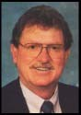

**Cecil Williams**

1993

President: Cecil Williams



Vice Presidents: Dick Zumwalt, Jack Starr

Treasurer: John Zoller

Pres Elect: Jack Graf Jr.

Directors: Keith Glover, Rick Rinderle, Dan Bernacki, Bob Markwart, Connie Breedlove, Doug Kidd, Greg Gilmer, Bill Weber, Gary Lombard, Jerry Reynolds, Ken Monnin, John Carl Jr.

Managing Director: Chris Long

During the year, DODA adopted a residential operator installation statement for operators.

The FWGDA/DODA joint venture Convention & Exposition was very successful. Lou Holtz, head football coach, University of Notre Dame was the keynote speaker. The event drew

3,178 attendees – an industry record.

Several changes were made to the association’s bylaws.

It was confirmed that the 1994 Convention would be conducted in Minneapolis, Minne- sota, June 16-18. Lee Greenwood was the performer for the President’s Banquet, and Harvey MacKay, a business leader was the keynote speaker.

The association produced hangtags for dealer use with non-UL325 compliant operators. Tags were produced for California, Minnesota, and New York. A generic tag was produced for all other states.

ARDI produced a Rolling Fire Door Inspection and Drop Test form.

The association published its first Annual

Report.



**Cecil Williams**

The Board approved the production of a management seminar and ski outing for the membership to be held in Breckenridge, Colorado, January 27-31.

1994

President: Jack Graf Jr



Vice Presidents: John Zoller, Gary Lombard

Treasurer: Jack Starr

Directors: Dan Apple, Dan Bernacki, Greg Gilmer, Keith Glover, Doug Kidd, Pat Lohse, Rick Rinderle, Ken Roehl, Jim Shea, Bill Weber, Dick Zumwalt, Cecil Williams Managing Director: Chris Long

On November 18, 1993, the Michigan Door & Operator Association became the first DODA Affiliate member.

On January 14, 1994, representatives of

FWGDA and DODA met in Phoenix, Arizona

to finalize an Agreement of Merger. The meet- ing was very positive and resulted in a unani- mous approval.

The 1994 Convention & Exposition was con- ducted in Minneapolis, Minnesota, June 16-18. It was a very successful convention. John Carl, Jr., presented a $5,000 check to the Executive Director of the Child Abuse Center, Midwest Children’s Resource Center, Children’s Hospi- tal of St. Paul.

The Breckinridge educational seminar and ski outing attracted 31 attendees.

The association’s magazine was being distrib- uted to 10,000 readers.

During the year, Tom Cordonnier celebrated 40 years in the garage door industry.

The merger of FWGDA and DODA was set to transpire on January 1, 1996. DODA and FWGDA Committees began working together prior to the official merger date.

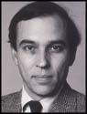

**Jack Graf Jr**

During the year, the Canadian Door Institute decided to cease production of its annual convention, and participate in the International Garage Door Exposition instead.

The Indiana Door Dealers Association be- came an IDA affiliate member.

It was decided that the 1995 Exposition would be conducted in New Orleans, Louisiana, May

18-20, and would be sponsored by both

FWGDA and DODA.

1995

President: Jack Graf Jr



Vice Presidents: Mike Truman, Bill Wahler

Treasurer: John Zoller

Pres Elect: Bill Walker

Directors: Dan Apple, Dan Bernacki, Bob Cookson, Greg Gilmer, Don Harrison, Pat Lohse, Flossie Miller, Bill Mohler, Ed Niit, Ken Roehl, Sonny Wilson, Bill Winser

Committee Members: Gary Lombard, Garry

Stewart, Cecil Williams

Executive Director: Chris Long

The New Orleans Convention & Exposition was a great success with 3,000 in attendance. During the Exposition, the Oklahoma City Relief Fund was awarded $2,500 by the asso- ciation. A check was presented to DODA member, Jim Tull. The keynote speaker was Terry Bradshaw, and the entertainer for the President’s Banquet was singer, Mary Wilson.

The 1996 Exposition was set for Las Vegas, April 25-27.

The association’s High Roller Club picked up momentum, as members recruited new mem- bers.

It was reported that during the Exposition in Las Vegas, an Industry Education Foundation (IDEA) would be created. The Foundation will develop and administer a dealer certification program.

The Regional Educational programs were coordinated by both FWGDA and DODA.

DODA introduced the release of a dealer

OSHA compliance program.

*On December 31, 1995, the FWGDA and DODA ceased operation, and on January 1, 1996, the International Door Association began operation.*



**Jack Graf Jr**



Heritage of the International Door Association 59

**Reflections From a Historical Mirror**



Reprinted from the May 1997 issue of International Door & Operator Industry

When one looks upon the historical mirror of the International Door Association, the reflections of numerous industry leaders appear. Some of these leaders served as President, an honor experi- enced by only a few. Being one of these few, I will soon conclude my term, and will one day peer out from the historical mirror, too. One common element of all past presidents is their desire to reflect on their accomplishments, and the accomplishments of their respective Boards. I am certainly no different in this respect because I, too, wish to reflect and to express my gratitude to a number of people.

First, let’s begin with the pre-merger Boards of the Far Western Garage Door Association and the Door & Operator Dealers Association. Without these men and women and their extreme dedica- tion to the garage door dealer, we would not, today, be enjoying the value of the vibrant trade association, the International Door Association.

During the merger, these two Boards of Directors compiled all of their individual committee goals into the “Best of both Worlds.” This compilation of association activity created eleven individual committees and committee work schedules which currently takes one entire day of meetings. Each meeting has a specific agenda and is administered similar to previous association Board meetings. Most of the ideas and discussion of association business is derived from IDA commit- tees. Establishing these working committees was a major step forward for the merged associa- tion. This past year each Chairperson established a Committee Mission Statement that en- hances the IDA Mission Statement: “To Develop and Promote Door Dealer Excellence.”

I won’t bore you with the rhetoric and statistics, but I will state that the IDA has an outstanding Board of Directors. The Board continues to place door dealers as their number one priority! In recognizing a few highlights of this past year, it is important to acknowledge the fact that the IDA Executive Committee has directed the association’s Strategic Planning Committee to conduct an annual review and planning session. The future success of the IDA will depend highly on the meaningful research, analysis, and input of the Strategic Planning Committee.

The Safety and Insurance Committee, under the leadership of Dan Bernacki, has created a Safety Manual worth twice one’s annual association dues. It is a manual produced for door dealers by door dealers with the advice and counsel of a safety specialist.

The Dealership Marketing Committee, thanks to Bill Wahler, produced a second edition of the meaningful brochure, “How To Select A Door Dealer.” The Legislative and Regulatory Committee, chaired by Ed Niit, kept a careful watch on state legislative activity so that we would not be caught off guard by the introduction of any new legislative or regulatory action.

The Membership Recruitment and Retention Committee, faced with the inherent confusion of the merged association, two different dues structures, and dues anniversary dates, met the challenge with tremendous success. Dealer Vice President, Bill Winser, Cambridge, Ontario, Canada, took the Moosehead by the horns (antlers) and put the association on a pathway of growth.



The Nominating and Heritage Committee, led by Flossie Miller, made a new and major move by announcing the recipients of the IDA Industry Awards prior to the annual Exposition. Having always been a surprise announcement during the Exposition, the secrecy of the award presenta- tion was difficult to maintain and to keep special. Now, we can congratulate the honorees prior to, during, and after the Exposition.

In my opinion, the contribution the IDA has made to the Institute of Door Dealer Education & Accreditation (IDEA) is definitely the most significant highlight of the past year. IDA Director and IDEA President, Dan Apple, served as a catalyst to the dealer accreditation program. My per- sonal gratitude is extended to the IDEA Foundation Board comprised of IDA, DASMA, and ARDI representatives. The IDEA is now prepared to take door dealers to a new height of their profes- sion. The first examinations for accreditation will be presented in Nashville, Tennessee during Expo ’97. I encourage every serious garage door dealer throughout our international membership to attain the highest, professional designation possible. I urge you to become an IDEA Accred- ited Door Dealer!

In addition my gratitude is extended to the hard work of Ken Roehl, Chairman of the Finance Committee; Bill Winser, Chairman, Publications & Services Committee; and Don Harrison, Chair- man, Regional/Affiliation/Education Committee.

Leading this association has truly been the apex of my thirty years in the Garage Door Industry. It has been an honor and a privilege to serve door dealers throughout the international arena. As I covered previously, many past and present directors, committee members, and association leaders have made an everlasting impression on me. Because of their previous contributions and current service, I was truly able to serve you better.

In a very personal context, I thank Pat Kelly, Holmes Halley Industries, for getting me initially in- volved. A special thanks to Bob Cookson, The Cookson Company, for preparing me for the merger. Jack Graf, Jr., my counterpart president, thank you for your numerous contributions as you and I helped design the new IDA structure. To John Zoller, the IDA president-elect and Expo ’97

Chairman, thank you for contributing so much to the industry we share. To Trudy, my wife of 32 years, thank you for your support; without it I could not have served. To the entire IDA membership, thank you for allowing me to serve you.

Bill Walker

President’s Commentary

1996

President: Bill Walker



Vice Presidents: Bill Wahler, Bill Winser

Treasurer: Ken Roehl

Pres Elect: John Zoller

Directors: Dan Apple, Dan Bernacki, Ted Billman, Greg Gilmer, Don Harrison, Pat Lohse, Flossie Miller, Ed Niit, Dennis

Schlabach, Mike Schafer, Garry Stewart, Henry

Tarnow

Committee Members: Guy Bagger, Jack Graf

Jr., Gary Lombard, Mike Truman

Executive Director: Jim Weir

1996 began with merger of FWGDA and DODA to form the International Door Associa- tion. The primary reason for the merger was to focus on and enhance the education and success of all members.

The Institute of Door Dealer Education and Accreditation (IDEA) was created to help IDA achieve its mission. The Board of the IDEA was finalized during the IDA Regional Confer- ence conducted in Seattle, Washington, in November 1995.

In 1996 the Exposition was conducted in Las Vegas, Nevada, with Faith Popcorn as the keynote speaker, and featuring The Smothers Brothers and entertainment for the President’s Banquet. The event was very successful with

400 Canadians present. CDI won the “Share the Wealth” award for the most affiliate asso- ciation members in attendance.

The High Roller Club was acknowledged to create long-term growth of the IDA by giving national recognition and special incentive awards to member company representatives for recruiting new member companies.



**Bill Walker**

1997

President: John Zoller



Vice Presidents: Bill Wahler, Bill Winser

Treasurer: Dennis Schlabach

Imm Past Pres: Bill Walker

Directors: Dan Apple, Ted Billman, Keith Bomholt, Jerry Buckley, Michel Gendreau, Greg Gilmer, Don Harrison, Jerry Kenaga, Havard Macik, Shannon McGrady, Ed Niit, Garry Stewart, Henry Tarnow

Executive Director: Jim Weir

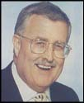

**John Zoller**

The 1997 Exposition was conducted in Nash- ville, Tennessee, May 14-17. Pat Williams was the keynote speaker, and the entertainment for the President’s Banquet was Willie Nelson. Kids on the Block received the $5,000.00

Tancil A. Horne Charity Award. IDA published a Forms Book.

The month of March was declared, “Garage

Door Safety Month.”

During the year, the new IDEA Accreditation brochures became available. The brochures provided a comprehensive overview of IDEA’s curriculum, accreditation procedures and benefits, the purpose of the IDEA, and pro- vided a new and improved testing application and form.

The first-ever IDEA accreditation examinations were held during the Expo in Nashville. A total of 40 students took at least one exam, and most took all six exams. In addition, 22 firms

have completed all six exams, and have fulfilled all other accreditation requirements, and now became the industry’s first accredited door dealers (August 4, 1997.)

In the May issue of *International Door & Op- erator Industry,* President Walker’s editorial was entitled, “Reflections From A Historical Mirror.” The article covered the highlights of the association’s formation from the FWGDA and DODA. He stressed the fact that IDA was the “Best of both Worlds.”

The 1998 Exposition was scheduled for Ana- heim, California. Joe Theisman was the keynote speaker, and Warren Greshes was the closing session speaker. The entertainment

for the Expo was none other than the

Beachboys.

1998

President: John Zoller



Vice Presidents: Shannon McGrady, Garry

Stewart

Treasurer: Dennis Schlabach

Pres Elect: Bill Winser

Imm Past Pres: Bill Walker

Directors: Joe Earwood, Ted Billman, Keith Bomholt, Jerry Buckley, Michel Gendreau, Don Harrison, Jerry Kenaga, Havard Macik, Ed Niit, Henry Tarnow, Inez Van Meter, Jim Lett Managing Director: Chris Long

The IDA Exposition was conducted in Ana- heim, California, and was very successful with

3,531 in attendance. A record number of exhibitor personnel attended: 1,182. Eleven workshops were presented and 156 exhibitor companies attended. The Taller San Jose House was presented the Tancil A. Horne Charity award of $6,200.

President Zoller presented DASMA president, Geoff Foreman with a check in the amount of

$20,000 to support DASMA’s Consumer

Awareness Program.

The association introduced a newsletter for members, *Insider News.*

The IDEA test sites expanded. As of Decem- ber 1, 1997, 39 dealers had become certified.

Garage Door Opener Warning labels were made available to the membership.

Bill Winser, W. R. Winser, Enterprises, Inc., Cambridge, Canada, and Eduardo Torres, ACE Doors, Carolina, Puerto Rico become first two dealers outside the U. S. boundaries to become accredited.

Creative Door Services received the first

International Dealer of the Year award.



**John Zoller**

President Zoller spoke at the DASMA annual meeting of members in Miami, Florida. He stressed the fact that IDA and DASMA share a common mission: to grow the garage door systems industry, and to help the participants in the industry grow professionally.

The association adopted a Code of Business Conduct for voluntary use by IDA dealer mem- bers.

The IDA website was greatly enhanced.

On June 5, 1998, IDA president John Zoller, past president, Bill Walker, and Managing Director, Chris Long met with the Board of Directors of the Association of Garage Door Specialists in Bolton, England.

The Board of Directors met at the Royal York Hotel in Toronto in November, and was very impressed with the hotel and Toronto. Toronto was confirmed to be the site for the 1999

International Garage Door Exposition..

During the year, IDA director, Keith Bomholt was interviewed by *Good Morning America*’s Spenser Christian.

1999

President: Bill Winser



Vice Presidents: Jerry Buckley, Garry Stewart

Treasurer: Dennis Schlabach

Imm Past Pres: John Zoller

Directors: Shannon McGrady, Joe Earwood, Ted Billman, Keith Bomholt, Michel Gendreau, Don Harrison, Jerry Kenaga, Havard Macik,

Ed Niit, Henry Tarnow, Inez Van Meter, Jim Lett, Steve Kalenich, Randy Moore

Managing Director: Chris Long

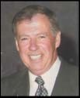

**Bill Winser**

The 1999 Exposition conducted in Toronto met or exceeded the expectations of everyone.

The total attendance was 3,527. The Tancil A. Horne Charity recipient was an international organization headquartered in Toronto – Free the Children. A $5,000 donation was made to the organization by the IDA.

The Exposition featured keynote speaker Barry J. Gibbons, and the musical entertainment of The Irish Rovers.

A Dealership Marketing Manual was unveiled and released in April.

The IDEA reports that nearly 100 dealers are now accredited. The first husband and wife team achieved accreditation – Havard And Donna Macik, LaGrange Overhead Door.

The association published a special issue of

its magazine directed to architects. The maga- zine was mailed to 10,000 architects in the United States and Canada.

On December 2-4, the City of Dayton, Ohio USA was the site for another series of interna- tional meetings. Leaders from thirteen door dealer based trade associations met to partici- pate in the inaugural IDA Affiliate Leadership Development Conference.

2000

President: Bill Winser



Vice Presidents: Joe Earwood, Randy Moore

Treasurer: Dennis Schlabach

Pres Elect: Ed Niit

Directors: Ted Billman, Keith Bomholt, Jerry Buckley, Michel Gendreau, Don Harrison, Steve Kalenich, Jim Lett, Randy Oliver, Garry Stewart, Mark Stuenkel, Henry Tarnow, Inez Van Meter, Bill Wahler

Imm Past Pres: John Zoller

Managing Director: Chris Long



**Bill Winser**

Bill Winser became the first international president of the International Door Association.

Colorado Garage Door Service became the first accredited dealer of 2000!

June was confirmed as being Garage Door Safety Month. Both IDA and DASMA partnered to produce a national consumer awareness program.

As IDA moved into the month of April, its dealer membership included 1,142 firms – a growth of 156.

IDA members Dennis Schlabach, Denco Marketing, and Ed Niit, Doors Systems, Inc., received watches for recruiting a minimum of

25 new members. They joined IDA Board member Bill Wahler who had previously re- ceived his watch for the achievement.

As of May 22, 452 dealer members had volun- tarily subscribed to the association’s Code of Business Conduct (41%).

The Exposition Committee, chaired by Ed Niit set an attendance goal of 4,500 for the Toronto Exposition. The final count was 4,617. The number included 1,431 dealer firms and 3,108 dealer personnel.

The Strategic Planning Committee and the IDA Board commissioned Julie Elberson, Elberson Marketing to study the purchasing habits of the typical IDA dealer members. The results of an extensive survey were compiled by Ms. Elberson for the Board’s use.

It was decided that future Exposition’s would recognize deceased leaders.

On July 1, 2000, Gary Lombard became president of the IDEA.

2001

President: Ed Niit



Vice Presidents: Garry Stewart, Joe Earwood

Treasurer: Dennis Schlabach

Imm Past Pres: Bill Winser

Directors: Ted Billman, Keith Bomholt, Jerry Buckley, Joseph Chisholm, Michel Gendreau, Jim Lett, Randy Moore, Randy Oliver, Tom Schafer, Mark Stuenkel, Henry Tarnow, Inez Van Meter, Bill Wahler

Managing Director: Chris Long

The year began with a complete overhaul of the

IDA website.

An installer certification program was unveiled during the Framingham Educational Confer- ence by IDEA Managing Director, Todd Tho- mas.

The International Garage Door Exposition was conducted in Atlantic City with the keynote speaker being Pat Croce. The theme of the Expo was “Under the Boardwalk.” For the first time, attendees were able to register for the Expo via the Internet. IDA leader, John Zoller was awarded the Jerry R. Reynolds Volunteer Leadership Award.

Due to the Internet, a Korean-based company was drawn into the IDA.

A special issue of *International Door & Opera- tor Industry* was distributed to 12,000 metal building contractors and erectors.

On June 22, 2000, the IDA Board of Directors took action to establish the IDA Scholarship Program. The first IDA scholarships were awarded to 10 students for the Fall semester,

2001. The association provided $250,000 to underwrite the program.

The IDA initiated an extensive consumer awareness program.

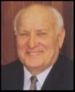

**Ed Niit**

The association recognized the top 100 door dealers (by sales volume) in *International Door*

*& Operator Industry.*

While the majority of IDA members are located in the United States, the association is truly worldwide. The IDA is represented in 25 countries.

2002

President: Ed Niit



President-elect: Garry Stewart

Treasurer: Randy Oliver

Imm Past Pres: Bill Winser

Dealer Member VP: Randy Moore Industry Member VP: Michel Gendreau Directors: Dan Beckley, Keith Bomholt, Jerry Buckley, Joseph Chisholm, Joe Earwood, Bob

Hammersley, Steven Harris, Dave Haslam, Luckie Jennings, Jim Lett, Tom Schafer, Mark Stuenkel, Inez Van Meter, and Bill Wahler

Managing Director: Chris Long



**Ed Niit**

What a great year! 2002 was truly a benchmark period for the International Door Association. The association’s Mission Statement was changed to read, “Enhancing the value of door and access systems dealers.” On December 31, the membership reached an all time high with 1,677 total companies. This magnificent growth was the result of the association’s continuous mission of serving door and access systems dealers, and those who provide our industry with products and services.

During 2002, the association’s scholarship program was elevated to a much higher level. It became an entirely separate Foundation, and was acknowledged by the Internal Revenue Service as a 501c3 education foundation. In the fall of 2002, eight scholarships were renewed, and eight new scholarships were granted for a total of sixteen!

The International Garage Door Exposition was con- ducted in Nashville, Tennessee as attendees were treated to their very own hit recording, “Garage Door Man.” The keynote speaker was Mark Victor Hansen, and the following individuals or firms were recognized with IDA Awards:

Distinguished Service Award: Willis Mullet, Wayne-Dalton Corporation

Industry Member Award: The Cookson

Company

Joe A. Caputo Dealer of the Year Award: Rinderle Door Company

Jerry R. Reynolds Volunteer Leadership Award: Gary Lombard and Kevin Pettiette

Presidential Service Award: Randy Oliver

Director Service Award: Ted Billman, Dennis Schlabach, Henry Tarnow, Randy Moore, Garry Stewart, and Steve Kalenich

International Dealer Award: DOR-CO Sales & Service Ltd.

Tancil A. Horne Charity Award: High Hopes of

Nashville

For the second consecutive year, the association recognized the top 100 door dealers (by sales volume) in *International Door & Operator Industry.*

The association’s bylaws were amended to describe *door dealers* as *door and access systems dealers*. In addition, several automatic pedestrian door distribu- tors joined the association adding a new dimension to the dealer membership.

The annual, two-day Strategic Planning Committee meeting was rescheduled immediately prior to the annual January Board meeting. By doing so, initiatives developed by the SPC could immediately be conveyed to the association’s operating committees for immedi- ate action.

The association’s Board initiated action to investigate restructuring the association’s operating committees.

The management staff provided the leadership with a five-year comparative of financial statements. This comparative significantly aids the Board and operating committees by enhancing thinking and planning.

2003 & 2004

**2003 Officers and Directors**



President: Garry Stewart Past President: Ed Niit Treasurer: Randy Oliver

Dealer Member Vice President: Randy Moore Industry Member Vice President: Dave Haslam Directors: Dan Beckley, Joseph Chisholm, Joe

Earwood, Jim Giles, Bob Hammersley, Steven Harris, Jim Jacobsen, Luckie Jennings, Jim Lett, Paul McManus, Tom Schaefer, Mark Stuenkel, Inez Van Meter, and Bill Wahler

Managing Director: Chris Long

**2004 Officers and Directors**

President: Garry Stewart Past President: Ed Nitt Treasurer – Bob Hammersley

Dealer Member Vice President: Mark Stuenkel Industry Member Vice President: Dave Haslam President-elect: Jim Lett

Directors: Dan Beckley, Joseph Chisholm, Jim Giles, Steven Harris, Jim Jacobsen, Luckie Jennings, Paul McManus, Randy Moore, Rich Nolda, Randy Oliver, Tom Schaefer, Bill Wahler, P J Walker,

and Scott Wilson

Managing Director: Chris Long

During President Stewart’s term as president several firsts were accomplished along with many traditional events enhanced. Special project funding was

made available from IDA to IDA Affiliates. A major undertaking by IDEA and IDA was the creation of the “Raising the Door Tour.” The “Tour” developed

to provide educational programming throughout the United States and Canada and to make available onsite testing for IDEA accreditation.

An IDA Code of Conduct was adopted for Door and Access Systems Technicians, and the association recognized the “Top 100 Door Dealers” featuring them in *International Door & Operator Industry* magazine. The IDA Scholarship Foundation awarded

10 scholarships.

A special industry pioneer, Norman Miller celebrated his

90th birthday. The 2003 IDAExpo introduced the first SuperTech Workshop. IDA conducted a Business Opin- ion Survey, and a meaningful collaboration between the IDA and IDEA resulted in the production of the DoorTech DVD Technician Training Series. IDA conducted the first Door Industry Congress in Dayton, Ohio.

**Garry Stewart**

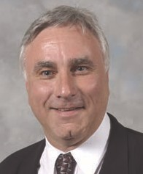

**Recognition awards presented during the 2004**

**IDAExpo in Las Vegas:**

• Joe Caputo Dealer of the Year – Virginia Door Inc., Chesapeake, VA

• Jerry R Reynolds Volunteer Service – Dennis Schlabach

• Industry Member Award – The Chamberlain Group

• Distinguished Service Award – Michel Gendreau

• International Dealer of the Year – Alberto Del Callejo, Tijuana, Mexico

• Presidential Service Award – Inez Van Meter

**Recognition awards presented during the 2005**

**IDAExpo in Nashville, Tennessee:**

• Joseph Caputo Dealer of the Year – Omaha Door and Window Company, Omaha, Nebraska

• Industry Member Award – Clopay Building Products

• Distinguished Service Award – Jack Graf, Jr., and Bill Walker

• Jerry R. Reynolds Volunteer Service Award – Randy Moore

• International Dealer of the Year – Select Overhead Door Service

• President’s Service Award – Randy Oliver

• Heritage Award – Ray Neisewander, Jr. and his late father, Ray, Sr., and Jerry Kenaga and his late father, Paul (recipients of first Heritage Award)

• Special Recognition Award – Long & Associates, Inc.

• Globe Award – Ed Niit

2005 & 2006

**2005 Officers and Directors**



Jim Lett: President

Past President: Garry Stewart

Treasurer: Bob Hammersley

Dealer Member Vice President: Mark Stuenke Industry Member Vice President: Rich Nolda Directors: Dan Beckley, Joseph Chisholm, Jim Giles,

Dave Haslam, Jim Jacobsen, Luckie Jennings,

Paul McManus, Dan Murdock, Randy Oliver, Robin

Oliver, Jim Pickhardt , Tom Schafer, Bill Wahler, P J Walker, Scott Wilson, and Michael Beltrami (replaced Jim Pickhardt)

Managing Director: Chris Long

**2006 Officers and Directors**

President: Jim Lett

Past President: Garry Stewart

Treasurer: Bob Hammersley

Dealer Member Vice President: Tom Schaefer Industry Member Vice President: Paul McManus Mark Stuenkel – President-elect

Directors: Dan Beckley, Michael Beltrami, Cathy Buckingham, Joseph Chisholm, Jim Giles, Dave Haslam, Luckie Jennings, Lance Little, Patti McCombs, Dan Murdock, Rich Nolda, Robin Oliver,

P J Walker, and Scott Wilson

Managing Director: Chris Long

As IDA entered its second decade, and during the presidential term of Jim Lett, several goals were established including: improving relations with DASMA and ARDI; enhancing Garage Door Safety Month; and developing a program directed to Home Inspectors.

The Raising the Door Tour created in 2004 was conducted in

29 cities. The IDA Scholarship Foundation reached $500,000 in scholarship awards. The IDAExpo featured the inaugural “Poker Run” raising $2,055.00 for the IDA Scholarship Foundation. In addition, the IDA Scholarship Foundation conducted a Mustang automobile raffle as fundraiser.

During his term as president, Jim Lett and the Board welcomed Canada as Region 10. A Membership Survey conducted with a total of 7,330people surveyed. A DASMA/ IDA Safety Awareness Program (CD) was introduced.

One will never forget Katrina and the devastation it created in New Orleans; IDA did what it could to assist members impacted by the storm. An IDA/CDI Educational Conference was conducted in British Columbia, and the late Alberto Del Callejo Badillo was named the IDA Advisor to Mexico.

With the loss of IDA director Jim Giles, Lorraine Giles filled the director seat of her late husband.

IDA Director Rich Nolda and Patty were married in Hawaii

January 15, 2006.

**Jim Lett**

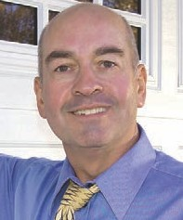

DASMA and IDA launched GarageWowNow.com, a public awareness program featuring a website directed to residential consumers. Jim and representatives of the IDA meet with dealers in Australia as a new IDA Affiliate was formed.

IDAssurance, LLC, a captive insurance entity was launched.

**Recognition awards presented during the 2006 IDAExpo in Las Vegas:**

• Joseph Caputo Dealer of the Year – Cristar Garage Doors, Sterling, Virginia

• Jerry R. Reynolds Volunteer Service Award – Dewey Stewart

• IDA Distinguished Service Award – Andrew Cornell

• Industry Member Award – Murphy Industries

• President’s Award – Mark Stuenkel

• Heritage Award – Jim Pace

• Tancil A. Horne Charity Award – Camps for Blind Children

• High Roller Lifetime Achievement Award – Dennis Schlabach

(150 members recruited)

**Recognition awards presented during the 2007 IDAExpo in Orlando, Florida**

• IDA Joseph Caputo Dealer of the Year – J B Mathews

Company

• Presidential Service Award – Bob Hammersley

• Distinguished Service Award – Gerhard Rauch and Henry

Neels, Helton Industries

• Industry Member Award – Martin Door

• Heritage Award The Cookson Company

• The Globe Award – Garry Stewart

• Humanitarian Award – Norman Miller

(1st recipient of this award)

• IDA Special Service Award – Tom Schafer

• IDEA Commitment to Excellence Award – C H I Industries

• Tancil A. Horne Charity Award – Retts Syndrome Association of the United Kingdom

2007 & 2008

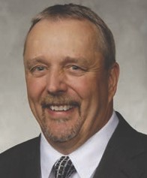

**2007 Officers and Directors**



President: Mark Stuenkel Past President: Jim Lett Treasurer: Luckie Jennings

Dealer Member Vice President: Bob Hammersley Industry Member Vice President: Paul McManus Directors: Dan Beckley, Michael Beltrami, Cathy

Buckingham, Lorraine Giles, Dave Haslam, Lance Little, Patti McCombs, Dan Murdock, Rich Nolda, Robin Oliver, Andy Pomroy, Glenn Tocci,

Scott Wilson, and Kevin Wetzel

Managing Director: Chris Long

**2008 Officers and Directors**

President: Mark Stuenkel Past President: Jim Lett Treasurer: Cathy Buckingham

Dealer Member Vice President: Michael Beltrami Industry Member Vice President: Paul McManus President-elect: Bob Hammersley

Directors: Joe Earwood, Bill Gibson, Lorraine Giles, Lance Little, John Mathews, Patti McCombs,

Dan Murdock, Rich Nolda, Robin Oliver, Andy Pomroy, Tony Price, Lyle Symons, Glenn Tocci, Kevin Wetzel, and Scott Wilson

Managing Director: Chris Long

During the presidential term of Mark Stuenkel, the association introduced SuperTech Day, a special day to recognize the industry’s door technicians for the value they provide each and every day. SuperTech Day was created utilizing a program of Merik Industries as its model.

The IDA expanded into Mexico with 52 distributors (dealers) added to the membership roles. The recently introduced IDAssurance, LLC reached $1,000,000 in premium written, and GarageWowNow.com, a public relations joint venture between the IDA and DASMA was enhanced to serve the industry to a higher level than before.

International Director, Robin Oliver, Oliver Overhead Door Company, Ltd., Brackley, Northants, England was elected. A very special program that provided doors to veterans of Operation Desert Storm - Opening Doors for Troops Program was conducted. In 2008, 18 Scholarships were awarded by the IDA Scholarship Foundation.

**Mark Stuenkel**

**Recognition awards presented during the 2008**

**IDAExpo in Las Vegas:**

• IDA Industry Member Award – Arrow Tru-Line

• Jerry R. Reynolds Volunteer Service Award – Bill Wahler

• International Dealer of the Year – Garage Doors & Gate Solutions Pty Ltd, Australia

• IDA Humanitarian Award – Garage Doors of Indianapolis

• Distinguished Service Award – Bob Bernard, National Door Industries

• Joe Caputo Dealer of the Year – Davis Door

Service, Seattle, Washington

• Presidential Service Award – Janet Lett

**Recognition awards presented during the 2009**

**IDAExpo in Nashville, Tennessee:**

• IDA Heritage Award – The Cornell Company

• Joe Caputo Dealer of the Year – Dan’s Overhead

Doors & More, Liberty, Iowa

• Humanitarian Award – Herb Brenner

(Posthumously)

• Industry Member Award – Haas Door, Wauseon, Ohio

• Jerry R. Reynolds Award – Randy Oliver

• Door Technician of the Year Award – Floyd Phelps, Crawford Door, Wilmington, NC (1st recipient)

• Globe Award – Jim Lett

• Distinguished Service Award – Roe Long-Wagner and Chris Long

• International Dealer of the Year – Overhead Door

Company of Ireland

• Presidential Service Award – Bob Hammersley

• Tancil A. Horne Charity Award – Chapel Hill House

2009 & 2010

**2009 Officers and Directors** President: Bob Hammersley Past President: Mark Stuenkel Treasurer: Cathy Buckingham



Dealer Member Vice President: Michael Beltrami Industry Member Vice President: Joe Earwood Directors: Wes Day, Bill Gibson, Alejandro Grossmann,

John Mathews, Patti McCombs, Dan Murdock, Shaun Murphy, Robin Oliver, Steve Pascuzzi, Tony Price, Lyle Symons, Glenn Tocci,

Kevin Wetzel, and Scott Wilson

Managing Director: Chris Long

**2010 Officers and Directors** President: Bob Hammersley Past President: Mark Stuenkel Treasurer: Cathy Buckingham

Dealer Member Vice President: Bill Gibson Industry Member Vice President: Patti McCombs President-elect: Michael Beltrami

Directors: Dan Beckley, Ty Collins, Wes Day,

John Dunn, Joe Earwood, Alejandro Grossmann, Ned Jones, John Mathews, Dan Murdock,

Rich Nolda, Shaun Murphy, Dan Nixa, Robin Oliver, Andy Pomroy, Steve Pascuzzi, Paul Peloquin,

Tony Price, Lyle Symons, and Kevin Wetzel

Managing Director: Chris Long

During the presidential term of Bob Hammersley, the

2nd Annual SuperTech Day was celebrated as more door technicians and installers were acknowledged for their industry contributions. A special IDAExpo Strategic Planning Committee met and developed

a plan for future IDAExpos. A price discount for exhibitors with continuous participation was adopted and the base square footage price increased.

For the first time in the association’s history, the Board included three directors from outside the United States: Cathy Buckingham (Canada), Robin Oliver (England), and Alejandro Grossmann (Mexico). The IDA was truly emerging into truly becoming

‘International’. The association participated in the

European trade show, R&T, Stuttgart, Germany.

UL 325 for Commercial Operators became

effective in August 2010, and the Garage Door

Activity Index was introduced as a feature of

*International Door & Operator Industry,* by

Dr. David Bowen and John Zoller.

**Bob Hammersley**

**Recognition awards presented during the 2010**

**IDAExpo in Las Vegas:**

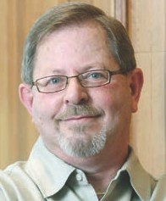

• Special Recognition Award from IDEA – Dennis Schlabach

• Industry Member Award – Garaga

• Presidential Service Award – Cathy Buckingham and Mark Stuenkel

• Distinguished Service Award – Bob Schram

(Posthumously)

• IDA Joseph Caputo Dealer of the Year Award – A&E Door Sales

• Jerry R. Reynolds Volunteer Service Award – Jack Graf, Jr.

• IDA Humanitarian Award – Chamberlain

• IDA Door Technician of the Year – Graeme Klooper, Australia

**Recognition awards presented during the 2011**

**IDAExpo in Indianapolis:**

• IDA Technician of the Year – Ed Vesbach

• IDA Industry Member Award – Re-Source Industries

• Dealer of the Year – PDQ Door Company, Hampton, Maine

• Heritage Award – Merchantville Overhead Door, Camden, New Jersey

• Jerry R. Reynolds Volunteer Service Award – Ted Billman

• International Dealer of the Year Award – Puertas

Automaticas, Mexico City

• Distinguished Service Award – Jack Ginther

• President’s Award – Bill Gibson and

Alejandro Grossmann

• Tancil Horne Charity Award – Wounded Warriors

• IDA Globe Award – Mark Stuenkel

2011 & 2012

**2011 Officers and Directors**



President: Michael Beltrami

Past President: Bob Hammersley

Treasurer: Cathy Buckingham

Dealer Member Vice President: Bill Gibson Industry Member Vice President: Joe Earwood Directors: Wes Day, John Dunn, Alejandro Grossmann,

Ned Jones, John Mathews, Patti McCombs, Gordon McGraw, Shaun Murphy, Dan Nixa,

Robin Oliver, Steve Pascuzzi, Paul Peloquin, Tony

Price, John Storey, Lyle Symons, and Kevin Wetzel

Managing Director: Chris Long

**2012 Officers and Directors**

President: Michael Beltrami

Past President: Bob Hammersley

Treasurer: Steve Pascuzzi

Dealer Member Vice President: Kevin Wetzel Industry Member Vice President: Lyle Symons President-elect: Bill Gibson

Directors: Dan Beckley, Chuck Colton, John Dunn, Joe Earwood, Alejandro Grossmann, Ned Jones, John Mathews, Gordon McGraw, Paul McManus, Flossie Mohler, Dan Nixa, Randy Oliver,

Robin Oliver, Paul Peloquin, John Storey, and

Bill Wahler

Managing Director: Chris Long

IDAExpo Strategic Planning Committee met to finalize future event vision and structure. The EPA Lead Based Paint Rule was activated, and the IDA responded keeping members up to date on requirements. The DoorTech Commercial Operator Troubleshooting DVD was produced and introduced to the membership. SuperTech Day celebrated its 4th Year

21 scholarships awarded byThe IDA Scholarship Foundation awarded 21 scholarships. The IDA *Human Resources Best Practices Guide* and *Employee Safety & Health Manual* were updated, and president-elect Bill Gibson made a presentation to the U.S. EPA regarding lead paint ruling for commercial doors.

**Michael Beltrami**

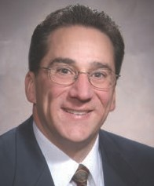

**Recognition awards presented during the 20012**

**IDAExpo in Las Vegas:**

• IDA Industry Member – Service Spring Corporation

• Distinguished Service – Dennis Schlabach

• Dealer of the Year – Broten Garage Door & Gate

• International Dealer of the Year – Diplas and Condoor

Industrial Door

• Jerry R. Reynolds Volunteer Service Award – Wes Day

• Presidential Service Award – Bob Hammersley

• Humanitarian Award – Humanitarian Award

• Heritage Award - Overhead Door Company of Colorado

• Tancil A. Horne Charity Award – Southern Nevada

Affiliate of the Susan G. Komen for the Cure

• Door Technician of the Year – Kyle Hart, Pete Howes, Craig Smith, Steve Mullins, Keith Northfeld, Duane Osterling, James Simmons, Danny Smyth

**Recognition awards presented during the 2013**

**IDAExpo in Nashville, Tennessee:**

• Special IDA Special Service Award – George Manaras

(Posthumously)

• Jerry R. Reynolds Volunteer Service Award – David Zigenhorn

• Distinguished Service Award – Dr. David Bowen

• International Dealer of the Year Award – Puertas

Automaticas Del Norte SA De CV, Cosme Lozano

• IDA Industry Member Award – Napoleon/Lynx

• Door Technician of the Year – Kyle Hart and Troy

Kilpatrick

• IDA Humanitarian Award – Overhead Door Company of the Meadowlands

• IDA Joseph Caputo Dealer of the Year Award – Hartland Overhead Door, Inc.

• IDA Heritage Award – Price Overhead Door

• IDA Globe Award – Bob Hammersley

2013 & 2014



**2013 Officers and Directors**

President: Bill Gibson

Past President: Michael Beltrami

Treasurer: Steve Pascuzzi (2013-2014)

Dealer Member Vice President: John Mathews Industry Member Vice President: Dan Nixa Directors: Chuck Colton, Chris Cunningham,

Joe Earwood, Alejandro Grossman, Ned Jones, Gordon McGraw, Paul McManus, Flossie Mohler, Randy Oliver, Robin Oliver, Paul Peloquin,

Kevin Pettiette, John Storey, Jeff Smoker, Bill Wahler, Joel Yackee, and Lyle Symons

Managing Director: Chris Long

**2014 Officers and Directors**

President: Bill Gibson

Past President: Michael Beltrami President-elect: Randy Oliver Treasurer: Tim Matthews

Industry Member Vice President: Flossie Mohler Dealer Member Vice President: Paul Peloquin Directors: Miguel Acosta, Chuck Colton,

Chris Cunningham, David Dawdy, Bob Hammersley, Ed Hermanns, Jennifer Juhlke, Gordon McGraw,

Paul McManus, Keith Moore, Dan Nixa, Robin Oliver, Kevin Pettiette, Randy Schmitt, Jack Schram,

Bill Wahler, and Joel Yackee

Managing Director: Chris Long

One of the highlights I’d like to acknowledge is that at the conclusion of my term of office, we celebrated the 20th Anniversary of the International Door Association!

During my two years of service, the association’s leadership devoted its resources to providing valuable programs and services to the membership. Economic challenges, EPA regulations, roller coaster fuel prices, uncertain insurance availability, and overall escalating business expenses created issues, but IDA remained diligent in its commitment to represent the mem- bership thru it all. As a result, 93% of IDA members elected to renew their membership, and many others joined for the very first time.

**Let’s take a look at some important achievements of the IDA:**

To brand the IDA and drive business to its members, the association took advantage of new opportunities available via social media. In addition to YouTube, the association utilized Twitter, Facebook, and Linkedin to reach emerging markets, and very importantly, the younger generation.

IDA continued its efforts in helping dealers cope with managing the EPA document requirements. The IDA website provided helpful information regarding the requirements, and IDA attorney, Brian Schoolman, was a valuable resource for the membership.

The IDA sponsored website, GarageDoorCare drew a huge audience,

65,580 visits to be specific, and was a tremendous resource for consum- ers to learn more about maintenance and safety matters. Thousands of consumers viewed the site, and in turn, called on IDA members for advice and service.

A very special PR effort was launched for spring 2015. The program called for consumers to receive a maintenance service reminder from IDA twice annually. The end result - more business for the membership, and safer operated door systems!

In a joint effort with DASMA, IDA continued the utilization of GarageWowN- ow.com to help both associations create a broader awareness of how an attractive garage door enhances the appearance and value of a home.

**Bill**

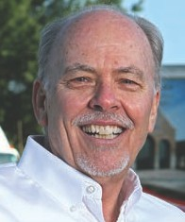

**Gibson**

The IDA website, dooreducation.com was expanded to include educational opportunities recognized by the IDEA for CEU requirements. Working with the IDEA, more and more programming will be added to the website.

In today’s marketplace, businesses and associations must have an appealing, easy to navigate website. IDA invested significantly to maintain a meaningful website for both members and the public. It introduced a separate website

in 2014 to cover various aspects of the IDAExpo, and the IDA Scholarship

Foundation website received a major re-do making it easier to use.

The mission of IDA continues to be: enhance awareness, professionalism, safety, and success of the door and access systems industry. This mission is supported significantly by the Accreditation and Certification programs of

the Institute of Door Dealer Education and Accreditation. IDA members have benefitted greatly from the work of the IDEA.

Insurance for dealers is a costly necessity of doing business. Through IDAssurance™ many IDA members enjoy broader coverage, competitive premiums, and superb service.

Without any reservation, the association’s leading publication *International Door & Operator Industry* continues to be enjoyed by thousands of readers throughout the United States, and beyond. The addition of the electronic version expanded the readership well beyond the borders of North America adding an almost infinite number of viewers. The electronic version provides immediate and direct contact with advertisers via the click of a mouse! Ad- vertisers in the magazine receive instant results!

The IDA provided support to dealer-oriented trade associations in the United States, Mexico, Canada, Great Britain, and Australia. These grassroots organizations provide additional programs and services to dealers and help the IDA achieve its mission as well. The IDA sponsored a Strategic Planning Meeting for the Affiliates in Savannah, Georgia which led to the development of a strategic plan for them.

In addition, International Director, Robin Oliver, and IDA Managing Director,

Chris Long, participated in the International Window & Door Summit held in Shanghai, China, and attended the Annual Conference of the European Door and Shutter Federation. As a result, a Memorandum of Cooperation was executive between the EDSF and IDA. In February 2015, the IDA was represented at the R+T Trade Show in Stuttgart, Germany where several new members and IDAExpo exhibitors were recruited.

Through the professional efforts and dedication of John Zoller and Dr. David Bowen, the IDA DEALER-FIT Program helped hundreds of dealers better understand the financial performance of their respective businesses. Each year the program improves and more and more dealers participate.

Another association service made possible by John Zoller and Dr. David Bowen is the ever-popular Garage Door Activity Index. It is one of the most popular features in the association’s magazine, International Door & Operator Industry.

Since the fall of 2001, the IDA Scholarship Foundation has granted a grand total of $906,650 in scholarships to well deserving students. This member service is not only one of those ‘feel good’ activities, but it has literally helped change the lives and present meaningful opportunities for IDA members,

their families and their employees.

We all know how important door technicians are to our industry and individ- ual businesses. That’s why the 4th Monday of June has been designated SuperTech Day by the IDA.

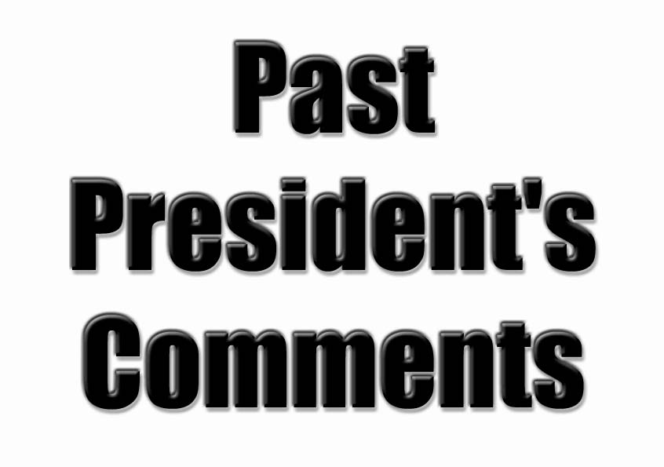

Heritage of the International Door Association

**Past President’s Comments**



**Bob Cookson**

My term as president of the Far West Garage Door Association was eventful to say the least. It was during that time that FWGDA and DODA agreed to merge to become IDA. While the seed for the merger had been planted long before I became president, some conversations I had with DODA president Cecil Williams were perhaps the serious beginnings of the events that led to the joining of the two associations.

Along the way there were innumerable meetings and many discussions, and I can say that they always centered around whether the proposed merger would be good for our members, the door dealers, and our industry. Ultimately this led to a positive vote of our members for the merger.

In a bittersweet moment I had the privilege of presiding over the last FWGDA convention. Our conventions were always fun affairs, and this one held in Reno (we loved to party) was no exception. There was a tinge of sadness knowing that this was going to be the finale mixed with the excitement caused by the new venture we were beginning. I also had the pleasure of turning over the leadership of FWGDA to our last president, Bill Walker. Bill did a masterful

job of what was a most difficult task, turning the concept of the merger into the reality. Our industry owes Bill a great deal of thanks for the wonderful job he did.

As always, for me, the highlight of my term were the people I got to know. We had a great group of officers and director and a fantastic management company, The Messersmith Group, led by Lloyd Messersmith and Teresa Stephenson. For me the Far West Garage Door Asso- ciation is gone but not forgotten.

**Past President’s Comments**



**Ken Roehl**

During my term in office, the industry as a whole had begun to undergo a number of significant changes. Manufacturers were seeing increasing competition; regional manufacturers were seeing the expansion of more “national” manufacturers, and theses same national manufactur- ers were beginning to look toward more global expansion to sustain their continued growth. During these same years, there was a move toward industry consolidation as well. We had larger national manufacturers showing interest and actually begin to acquire smaller more regional manufacturers. The expansion of distribution center networks began to take shape, with door manufacturers pressing the issue of national exposure to smaller and larger dealers directly.

Building codes, safety concerns and product liability issues raised the flag that there was going to more issues of regulatory compliance in our future. The industry was clearly gaining more visibility. These issues as well as increasing competition from a growing number of smaller dealers (service by the distribution center network) forced the more established dealer base to look toward gaining more education, more business principles/disciplines, and estab- lishing competitive advantages to protect their marketshares.

During my term as president of FWGDA, conversations between John Carl, and myself presi- dent of DODA took place regarding the similarities of our dealer bases. It soon became evi- dent that the needs and desires of the dealers throughout North America were really the same. The expectations of the dealers from their respective trade associations were also

similar. There was strong support coming from the manufacturing members of both groups for consolidating the dealer organizations, realizing there would be a need for just one single trade show each year. The manufacturers felt so strongly about this consolidation, they agreed that excess profits from the first Expo event in 1993, would be used to fund what is

now the IDEA organization which is responsible for the continuing training and education of the dealer members of the combined IDA organization. Bob Cookson followed me as the next president of FWGDA. Bob along with Cecil Williams president of DODA, really were the individuals who took charge of the implementation of the merger and consolidation of the two dealer organizations.

In my career, this merger was one of the most meaningful changes we have seen within the industry. The benefits to all members whether, dealer or manufacturer are much improved from the earlier days.

**Past President’s Comments**



**Bud Whittemore**

When presented with the task of summing up the events of my year in office as D.O.D.A. President, I found it difficult to determine which of our many achievements to address. While it would be far too time consuming to list every action taken, I feel that it is important to re- member that these early years were paramount in determining the direction the association would take.

Of the different programs that were instituted at this time, the regional workshops are without doubt one of the most productive and long-lived. These workshops were attended by owners, managers, and technicians alike making them beneficial on both a business and technical level.

Much like today, the workshops would start with a general topic and a presentation by a fellow association member. The following question and answer sessions always proved to be ben- eficial to all involved and I feel that everyone always left with some piece of knowledge that they did not have when they arrived.

Another move during my tenure was the development of an office space for the production of the Door & Operator magazine. Prior to this time the magazine was being produced by a gentleman by the name of Tony Font. Tony was actually working out of the basement of his home to perform his jobs for the association. The Board of Directors agreed that we had grown large enough to rent our own office space so as that Tony would have an office to go to each day instead of down to his basement. Imagine our surprise when we discovered that we were renting the building from Tony himself and that he chose to move in to the upstairs floor. Apparently some things weren’t meant to change!

Finally, I would like to acknowledge the pride that I am sure I share with other past presidents of this time, such as Larry Donlin and Ron Nix, in how each year membership and attendance would grow incrementally. I am pleased to see how the association continues to grow and am confident it will continue to do so.

**Past President’s Comments**



**Tancil Horne**

I was elected president of DODA at the 1982 convention in Minneapolis, MN.

The American economy was in one of the recessions that has periodically plagued us since

World War II. As usual, the construction industry was particularly hard hit.

We tried to keep things upbeat, but sometimes all of our promotional efforts fell flat. For ex- ample, at a DODA workshop and tabletop trade show in Kansas City, the attendance was extremely poor. A head count showed that we had more factory employees at the trade show than door dealers.

In addition to the poor business climate DODA developed a very serious problem that threat- ened our very existence. In 1983, it became clear that we needed to use the services of a professional association management firm, replacing the individual that had managed the door dealer’s association since its very beginning. This search for new leadership turned up an association management company in Dayton, Ohio, experienced with construction related associations. We signed with Bell Publicom just before the 1983 convention in Cincinnati.

Everything went well for the first few months, and it was generally felt that we had made a good move. Then, the principal of Bell Publicon, Jerry Bell, was killed, in a private plane crash. In the turmoil that followed, near catastrophic financial practices came to light. Bell

Publicom had discovered that by co-mingling our funds for overnight investment with the funds of other associations under their management, the bank would , without our permission, use our funds to honor overdrawn checks from other Bell Publicom . When the bank discovered what had been going on, and the very large amount of money involved, they shut us down. DODA’s bank account was frozen. At that time, we had more than half a million dollars in the account in controversy.

DODA was dead in the water. We couldn’t pay any bills, we couldn’t make purchases or pay salaries. We didn’t even have telephone service since our phone had been cut off.

Jerry Reynolds, the immediate past-president, and I spent a lot of time on the phones, along with several trips to Dayton to consult with the remnants of Bell Publicom, and plead with bank officials and attorneys to release their grip on our money. Finally, after more than a month, we convinced them that a bank error caused all of this trouble, and they released our account.

**Past President’s Comments**



**Tancil Horne cont...**

Out of all conflict comes some good. And in this case, Jerry Reynolds and I were instrumental in convincing Chris Long, then an employee of Bell Publicom, to form his own association management team, and take over the management of DODA. This was the beginning of our long and very successful relationship with Long Management. I sincerely believe this relation- ship is directly resistible for the years of growth and progress of DODA and consequently IDA.

Although I didn’t feel that it was funny at the time, an occurrence at the Cincinnati convention in 1983 was later considered humorous. It was at that time that I learned to hide. Responsibil- ity shirking, confrontation avoiding, angry women hiding.

As we still do, one of the planned events at our convention is the special day of activities for the women of our organization. At Cincinnati we were scheduled for a day of sight-seeing, dining and shopping. A day that would warm the heart of the DODA ladies as well as the executives of all the major credit card companies.

About nine o’clock in the morning, the clans of shoppers began to gather just across the street from our hotel. Their mood was festive....at least for a while. About 9:30 many began to anx- iously ask about the arrival time for the chartered buses. By 10:00 the entire group was plainly agitated at the absence of transportation. The angry women were getting noisy.

At this time, I mistakenly made a presidential visit to the bus loading site.

Quickly spotted by the wannabe shoppers, I was soon surrounded, and forced to plead inno- cent of all charges. When I heard words like “lynch” and “tar and feather” and “impeach”, I made a quick exit with the promise that I would investigate and get right back to them.

The quick investigation showed that the person who scheduled the charter buses had set them up for the wrong day. The buses were not scheduled until the next day. I conned one of our vice-presidents into getting that information down to the unhappy crowd in an attempt to save my not-so-hairy scalp.

There were to be three bus loads on this tour, and each woman took an oath to read me the riot act, just for starters. After being accosted by several, I took the cowards way out and hid. Men’s rooms, my room, board room, any room that offered a degree of protection.

My skill at hiding preserved my presidency. With the cooperation of the charter bus company, we got the program underway on time the following day.

For any future presidents of the association, remember, “Hell hath no fury like a woman un- bused.”

**Past President’s Comments**



**Tony Rosso**

In the 70’s, when Frank Kallister and a few other Ohio Door people had this crazy notion of a forming a National Association for Door Dealers, they never dreamt that it would evolve into such a wonderful Association with a budget of over a million dollars and over 1000members.

As one may imagine, the concept of The Door and Operator Dealer of America (alias IDA ) was enthusiastically met by those of us who traveled to Ohio for a get together for a little Education.

The Ohio group suggested we start a National Organization and subsequently we voted a group of Dealers to a Board who in turn elected Lou Stepanik as president. The following year Joe Caputo was elected to his first term as President of the Association and I had the privilege of being elected to the Board.

One of the pressing things that needed to be attended to, was the Bylaws of the Association and Don Lahote, a few others and myself were given the task of producing an International Set of bylaws. The following year it was my turn to be elected president and with one full time

employee (Tony Font working out of his house) a budget of less than $20,000 we set our sites for big things. We finished the Bylaws, we started publication of our magazine and started to look for space for our offices.

The National Convention consisted of something slightly bigger than one of to days regional meetings, with about the same number of seminars. There was one thing that stood out at these gatherings, the attendees were there to learn and absorb all they could about there profession. The Seminars were, like everything else, where very low budget; a Board member, along with some of the Associate members, would lead the Forums on different kind subjects and we would explain the product, how it worked and what kind of marketing one could do with it. The response and participation were incredible. One particular instance stands out; having just finished a seminar on Rolling Steel doors, a gentleman with a nice friendly southern drawl came up to me and expressed his bewilderment about a product that yielded such great mar- gins and if I could give him more information, of course we did our best to help answer all his questions and thus emerged another Rolling Steel Dealer, his name, Jerry Reynolds who

every year after would not let me forget how he learned about Rolling Steel Doors.

The beginning was turmoil, but today it is a pleasure to see what a great, powerful Association we managed to conceive, nurture and develop. The past was great and the Association has given me fond memories to enjoy in my retirement.

**Past President’s Comments**



**David O. Martin**

One day in 1964, I received a telephone call from Roy Crawford who worked for a company in Redlands, California called Morgan Electronics. He asked if I would be interested in meeting together with a few door and operator dealers, manufacturers and suppliers the following spring in Las Vegas. He said his boss, Ralph Morgan, thought it would be a good idea and encouraged Roy to call as many as he could in the western U.S.A. He said that perhaps this could be the beginning of a garage door association.

Our first meeting/convention was held in Las Vegas, March 1965, at the Sahara Hotel. We only had about six product display booths and about 75 in attendance. We elected Ralph Morgan as our first two year President with Ted Ferrell (president of Linear Electronics Corp.) as Vice President. I was elected to the Board of Directors.

Our second Convention was at the Sahara Hotel in March 1966. Our product display booths and our attendance doubled for this convention. The third convention was also held at the Sahara Hotel In March 1967. Ted Ferrell became our second term President and Ethor Moore as 1st Vice President. I was elected as 2nd Vice President.

In 1969 I was elected as the third two term President. My Vice Presidents were Ray Williams, James Leech and Paul Halopoff.

I also remember in the 1970’s a man from Ohio by the name of Tony Font contacted me and asked if I would join a new eastern door association called DODA. They said they would like me to represent the western U.S.A. and be on the Board of Directors, which I accepted.

It has been a great opportunity to be able to work with great people in our industry over the years.

**Past President’s Comments**



**Jack Graf**

From the moment Ken Monin called me and asked if I would be interested in serving the Door and Operator Dealers Association in some capacity other than the panel speaker I had been honored to be; I knew I had been offered the chance to repay the Industry which has given my family the opportunity to live the American dream. At the time, Dealers were elected to an “at large” seat and therefore with a little politicking at national Overhead Door Distributors meet- ing, I was elected.

From my first board meeting in Nashville, I knew I would be able to work with the some of most qualified and dedicated people assembled in any industry. After I arrived I discovered that a suit was required dress for all the meetings. President Ken thought that the importance of the occasion required important attire. I hadn’t packed a tie (Nashville after all, I thought!) and had to buy one at Opryland for over $20.00 which back then was a lot of money. I wore that tie to every meeting until 1996 just to get my money back.

At the time our industry was fractured into many parts. Both product type and geography divided us and created unbearable friction and a great deal of mistrust amongst our parts. As a member of the largest of the pieces, DODA, I was privileged to witness some of the greatest planning exercises about our industry future. Our board had visionary thinkers who were able to lay aside the agenda of the group from which they were elected and do what was right for the door dealer. For instance, we had Jerry Reynolds, Keith Glover, Bob Markwart, John Carl, Gary Lombard, and Jim Shea. Some worked for large corporations and were therefore used to structured planning. Many were entrepreneurs and were therefore used to making quick deci- sions based upon the empirical data before them. This was the correct mix of participants for the day. They structured the meetings so that they could author an operational action plan by the end of the day.

In the late 1980’s various alliances were at work to put together a way to reduce the cost of marketing door systems products to door dealers thereby freeing resources to market them to the general public. The big box stores ware just becoming a darling of Wall Street and had not yet been forced to consolidate among them. By early the 1990’s the FWGDA and DODA annual trade shows had been targeted as wasteful. Bob Cookson and Cecil Williams repre- senting these two organizations began a dialog about merging them into one. Their vision was correct for our time. By merging the groups, the door dealer remained the leader of the indus- try, and precious financial resources would not diverted to marketing door product through a competing chain of supply.

**Past President’s Comments**



**Jack Graf Cont...**

Bill Walker and I were appointed to head the merger negotiations for our respective organiza- tions. It is my observation that each member of the respective boards of directors always voted what was right for the door dealer and therefore for our industry. For example, when it

was determined that regional voting for Directors was the only way to properly address dealer issues as they might arise; some had to yield their seat to another from their same region. They did so willingly, ready to serve at a future time. DODA had dealer members and associ- ate members (non-dealers) yet Far West had one membership comprised of both. All Board members agreed to resolve this issue by creating an industry member classification for non- dealers, while increasing their board representation by one seat. Door dealer control was thus preserved yet an avenue for a greater supplier contribution was created. In order to help regional groups to thrive in their local environments, the affiliate classification was created. It was warmly received by all the groups and was quickly subscribed.

We negotiators were in almost daily contact with each other. We didn’t have e-mail back then, to telephone calls had to do. Bill is a very small door dealer with less than 6 employees, while I do business in cradle of the door business and therefore have very aggressive marketplace. Bill and I would daily hammer out task lists and call sheets and go to it. We would report our successes the next morning, or in the alternative, the continuing “opportunity” we had with someone. Once that someone had became enlightened and in-step with a merger committee proposal, we would move on to another “opportunity.” Each of us enjoyed the full support from the Presidents of our associations, Bob Cookson, Cecil Williams and our staffs, Lloyd Messersmith, and Chris Long as we wound our way through that uncharted curving and

bumpy pathway. Sometimes we needed help and would call on help, John Zoeller, Dan Apple, Bill Moeller, Doug Kidd, Dan Bernacki, Don Harrison, to name but a few.

By the time Bill had become President of FWGDA and I of DODA; the talks were coming to a successful conclusion. After one of the final sessions in Las Vegas, Chris and I shared a taxi

to the airport. He was on the way to Dayton and I to Columbus, departing from adjoining gates within 4 minutes of each other. We began the ride by discussing the need for an educational foundation to conduct a certification process for the dealer. Funding might be achieved through a revenue sharing scheme at the convention to which the future (soon to be) industry

members would probably agree. We kept talking about it as we entered the airport and walked to the gate as our enthusiasm increased. The flight was called and we walked onto the plane

in animated discussion sitting next to each other as our seat assignments were in the same row. The plane was full when some fellow came with a ticket for the same seat number as I actually had. We called the flight attendant to sort it out. That is when she pointed out the window to the plane I was supposed to be on as backed away from the adjacent gate.

**Past President’s Comments**



**Jack Graf Cont...**

I called Kay at home to explain and while I could not see her; I knew what look was on her face. I had experienced it many times before when I was late to dinner with her because of some meeting or other. The family of a door dealer doesn’t necessarily have it easy.

The final convention co-sponsored by DODA and FWGDA was in New Orleans in 1995. Two days prior to opening, Bill and I held our last meetings with the dedicated boards of directors who had worked for many years for their association. It was a time of congratulation for a job well done and of sadness for the loss of their advice in the future. The next day the Interna- tional Door Association was born with its first fully empowered board meeting. It was a time of expectation for the exciting promise of future benefits to be offered to not only the door dealer but also the door industry as a whole. Bill and I worked not only with three boards but three staffs and affiliate stalls during that week. By Saturday night after Mary Wilson had finished her performance and the footlights were being removed, we were ready for a fine dinner. Trudy, Kay, Walker and Graf headed to Arnauds in the French Quarter to celebrate. We had a gourmet meal and afterwards decided to go the temporary casino to finish the night off. We walked the floor but lost Bill somewhere. We looked in the gardens outside but didn’t see him. We circled inside numerous times but could not find him at the tables nor shooting craps. We concluded he had taken a cab back to the Hyatt, so we went to the taxi stand to follow suit. While on her way to climb in to the car Trudy glanced behind a large column. There was William Walker, last President of FWGDA, President-elect of IDA, seated on a bench with his back resting against the stone pier; sound asleep in the warm night air. We all went immedi- ately home and slept till noon. The toil of transition to the IDA was indeed complete.

The International Door Exposition is usually the last weekend in April, which corresponds with my Birthday. The following year it was held in Las Vegas. It was my last (and only) year as President of IDA. We had completed a tumultuous first year; the learning curve being much greater than some had anticipated. The Board met on the day of the hospitality parties, which was unusual, but it was a different schedule for that year. At the end of the meeting, I began what I had intended to be my swan song, a farewell to my friends who worked so hard at trying to make my term successful. I couldn’t finish the speech, they cut me short. Into the meeting walked and I am not kidding, Marilyn Monroe singing Happy Birthday Mr. President. I was indeed her “President Jack” for the rest of the evening at the hospitality functions. I was a 49- year-old from Columbus, Ohio, President of an international association hosting an exhibition in Las Vegas with Marilyn Monroe on my arm. Only in America as Jack Starr would say—Only in America—.

Thanks for the great memories IDA, but more importantly, thanks for the life long friendships generated and the fellowship to come.

**Past President’s Comments**



**Cecil Williams**

One of the most significant events during my term as DODA’s president was working with both the DODA and the Far Western Boards to bring about the first joint Exposition in 1993. During the planning of this historical event, Bob Cookson and I met several times to discuss the possibilities of a merger between DODA and FWGDA. I will never forget my meetings with the DODA Strategic Planning Committee regarding the merger. The balance of my term was devoted extensively to the merger process.

When thinking of humorous happenings, one that certainly stands out is a Las Vegas meeting. Several directors and staff of Long & Associates came in late one night (or was it early one morning?), and as we passed the front desk we asked for a 6:30 a. m. wake-up call. The front desk clerk was somewhat taken back because it was already 6:00 a. m.!

During a significant DODA Board meeting (during Expo ’93), Roe had a television and mint juleps delivered to the Boardroom so that I could catch the running of the Kentucky Derby.

As for highlights, meeting and becoming friends with many people continues to be a bright light. People like: Jerry Reynolds, Tancil Horne, Ken Monnin, Keith Glover, John Zoller, Jack Graf, Jim Shea, Bill Walker, and many others.

Another highlight was having the responsibility of working with and interviewing various women and children abuse centers in the Expo cities. These centers ultimately received a contribution from the association via the Tancil Horne Charity program.

Last, but not least, I would be remiss not to recognize my association with Long & Associates, and its staff, and a lasting friendship with Chris Long, and Roe Long-Wagner.

**Past President’s Comments**



**John Carl, Jr.**

My thoughts on my year as DODA’s president are:

The IDA was born, sitting on a retaining wall, talking with my counterpart, Ken Roehl from FWGDA …

The IDEA was to become a reality…

DODA, FWGDA and NAGDM began to agree on common ways to improve our indus- try, and to actually initiate the implementation of some of those ideas!

During my term of office, new state and federal laws were enacted that made residential garage door openers safer. The discussions and product developments

that have come about, due to these new laws, have made us all more aware of the consumer safety issues in products sold and the installation and repair of those

products.

I still remember what a full plate my administration left for Ken Monnin and Cecil Williams. They, along with many other leaders, did an admirable job in getting the IDA to where it is today. I want to thank them all for their contributions of time,

ideas and energy.

Perhaps the most remarkable part of the association was the staff. I don’t believe any of this could have happened without the professional management teams of Long & Associates, and The Messersmith Group. Being an old “DODA” man, I especially want to acknowledge Chris and Roe for their patience, and as John Zoller would say, “persistence”.

The most memorable moment for me was attempting to convince the members of NAGDM during their annual meeting in Florida that our industry had a serious overcapacity problem that was not going to go away.

**Past President’s Comments**



**Bill Mohler**

As with most volunteer organizations the pay is lousy! However, the rewards are priceless! The friends gained, the professional growth and the personal satisfaction of helping an organization grow are lifelong rewards.

As I reflect on my memories of serving the FWGDA, I recall “The Good Old Days.” Back then, the FWGDA Board members and Spouses stuffed all the envelopes, licked the stamps and com- pletely organized every aspect of the association - with no financial reimbursement, I might add. Realizing this approach was not progressive and limited the growth potential of the organization; we “Stamp Lickers” suggested retaining a professional Management Company. The proposal met with much resistance from many of the Association Directors and a good part of the general membership. Well, we “Stamp Lickers” prevailed and I’m confident that most will now agree that the decision helped strengthen the association. With the assistance of a management company, FWGDA grew into a much more professional dealer organization offering greater membership benefits.

During my tenure as FWGDA President, our sister organization, DODA, was growing and had a different, more global vision of the future. The DODA leaders approached the FWGDA leaders with a suggestion to merge the two organizations. The FWGDA Board and Membership was extremely reluctant to even consider such a proposition. So, I was the messenger sent to inform DODA that FWGDA had no interest in merging the associations and the proposal was declined. We just weren’t ready at that time.

At one Convention Banquet I recall addressing the FWGDA Membership mentioning the “Big Garage Door in the Sky”. Well, the FWGDA & DODA merger was completed years later (with the support of many of us “Stamp Lickers”) and here we are; The International Garage Door Associa- tion, strong, global, progressive and dedicated to the Professional Dealer.

My sincere thanks to all the past, present, and future leaders of the now IDA. And a very special thanks to all those “Stamp Lickers” who served the association during my tenure as FWGDA President.

**Past President’s Comments**



**Bill Winser**

Creation of this book is probably a good starting point for my reflections. It started at a regional show in Detroit. Bob Schram, George Pike, Tony Rosso, and I were talking about the origins of the eastern associations. In our discussion, Bob said “Tony, you should know, you were the first president of ODODA – Ohio Door and Operator Dealers Association”. Initially there wasn’t total agreement. As I recall, Tony was in disagreement. My comment to the disagreement was “if you guys can’t agree on the history of the association we should look at getting our history on paper.” The board of IDA met the next week in Canmore Alberta and enthusiastically approved a motion

to create this book.

Membership growth was a critical issue with not only IDA but many organizations. Many organiza- tions were loosing members. In 1999 we left the Toronto Expo with 1195 members and amongst other issues, a firm resolve to increase membership. Staff was directed to locate an individual who would have the singular responsibility of managing membership growth and retention. Staff came through with flying colors and brought Debra Welhener into the association management team. When most associations were experiencing significantly reduced membership rolls, mem- bership growth at the end of my term in 2001 hit an all time high of 1534. Debra deserved much of the credit. She did a marvelous job communicating the benefits of membership. Contributing

factors to membership growth were: modifications to the High Roller program; web site enhance- ment; affiliate development support and programs development & enhancement. I would be remiss if I did not give a lot of credit to Dennis Schlabach whose tireless efforts promoting IDA were never ending and resulted in many new members.

The “International Door and Operator Industry” magazine subscription grew from 12,000 to

15,000. It was always a very good magazine and it just kept getting better and better.

The creation of “Staff Action Reports” was developed to enable staff to communicate with direc- tors on a regular short term basis, logging activity and progress on action items.

The Scholarship fund was initiated by Chris Long. The idea was quickly endorsed by the board and is clearly a marvelous project for our association. Any door dealer, employee of a door dealer or family members can apply. What a great investment in the future of today’s youth!

**Past President’s Comments**



**Bill Winser Cont...**

Coming to IDA from an affiliate organization, I was acutely aware of the difficulties regional asso- ciations face. CODA was having a regional show in October 1999. Our affiliate chair Jim Lett, Todd Thomas and I attended the show and had a meeting with George Chandler, president of CODA and vice president John McKinley. The issues facing CODA had a familiar ring. At the conclusion of the show, Todd, Jim and I met to summarize the meeting and hatched the idea of hosting a meeting for affiliate leaders. The board endorsed a program later that month and six weeks later we held our first ever “Affiliate Leadership Development Conference” in Dayton. This service to our “grass roots” friends is creating a solid foundation for industry leadership growth.

Marketing of IDA became a focus after hearing Barry Gibbons, our keynote speaker at Expo 99 in Toronto. His comments on the importance of brand recognition were absorbed by the board. Michael Overbay was added to the staff and immediately went to work on updating and upgrading our web site. Michael contributed greatly to the support of Jim Lett’s Member Services Committee and to the development of programs and promotion of the IDA name.

ASHI (American Society of Home inspectors), NFPA (National Fire Protection Association), AFA (American Fence Association), UL 325 and ARDI (American Rolling Door Institute) are organizations either directly or peripherally connected to IDA. We became members of these associations, sharing information and contributing the installing door dealers perspective to the benefit of all door dealers.

Our nominating committee, under the direction of Ted Billman was responsible for locating tal- ented people to serve on our Board of Directors and as IDA appointees to the IDEA. I vividly recall, in my early years, the difficulties in identifying and locating prospective members for the board. Ted’s committee developed a leadership grid for prospective members. This creative proactive approach helped develop my Board. The Board, in my term was a very cohesive, intelligent, hard working and dedicated group of leaders. They, with superb staff support, are responsible for the growth and progress of IDA in my term.

In summary, IDA growth, industry network development and this History Book would be the high- lights of my term from April 1999 to April 2001. Staff and the Board Members made it happen. The spouses, friends and families of Board Members and staff in many ways became a family. We share many fond memories.

Thanks for all the wonderful memories.

**Past President’s Comments**



**John Zoller**

In 1994, there were concerns about the viability of both garage door dealer associations, DODA and FWGDA. I was on the DODA board and worked on the merger of the two organizations into what is now IDA. My first thrill as President of IDA was actually taking over the gavel in Nashville in April of 1997.

My first convention as President in 1998 was a nail biter. The planning had been excellent, and the seminars were strong, but the early registration appeared weak. When we arrived at the convention, the convention center was still undergoing renovations, which severely impeded traffic patterns. Fortunately, the West Coast membership really came through and attendance, while not a record, was very good. Staff convinced me to appear on stage in an orange bathing suit (or were they boxer shorts?) and a coat and tie. It was great fun to give a check to the DASMA President, especially when photos I saw later made it look as if I just didn’t put on my pants for the occasion. Joe Theisman was the keynote speaker and I was his center in one of his gags.

The 1999 IDA Expo was the first to be held outside of the United States. There was much con- cern about the timing of having a convention in Toronto, Canada, especially during the last week of April. Weather can be very “iffy” in Toronto at that time. Another concern was that we had out- grown having just one hotel, so attendees would have to be outside if they could not or would not navigate the labyrinth of cover walkways between the buildings. Again, pre-registration was weak, and I was worried. Again, attendance was very good, over 3,800. The weather was perfect, high

60’s and sunny, however, those that left on Sunday and Monday traveled through a significant lake effect snow storm. We dodged a bullet. The Toronto Expo was a hugh success.

Another memory of the Toronto Expo was a near international incident. Staff had adorned the opening session with flags of the nearly 40 countries represented by attendees at the show. At the end of the opening session, IDA members from these countries, as well as IDA board members followed Scottish bagpipers from the meeting room carrying the flags up the escalators to the exhibit hall. As president, I led the way. The path we traveled, as well as the entrance to the

exhibit hall was lined with attendees. The flags were then placed in flat stands at the entrance to the exhibit hall. I felt very proud until a Chinese exhibitor accosted me to tell me he was terribly offended by this dramatic entrance. When asked why, he informed me that the Chinese attendees and exhibitors were from the Republic of China (Taiwan) and not from the People’s Republic of China (mainland China). With the help of a friend and fellow speaker who knew Toronto, we located the correct flag and replaced the incorrect flag within 50 minutes.

**Past President’s Comments**



**John Zoller Cont...**

During my two years as IDA President, I concentrated on making sure the association was fiscally strong, worked to improve relations with other door industry trade associations, and tried to im- prove our relationship with IDA affiliate groups. The merger of DODA and IDA started with new association management that did not work. Past President Bill Walker and his board made the decision to employ Long And Associates. With all of the turmoil of an unhappy experience with

the old management group, and the start up expenses of a new association, we needed to replen- ish the association’s coffers. By the end of my second year, IDA was in good financial condition.

The merger of Far Western Garage Door Association (FWGDA) and the Door and Operator Dealers Association (DODA) was accomplished in a short amount of time, and several other industry trade associations were caught off guard with the quick change. By meeting with other industry leaders, attending their meetings, and communicating with their association manage- ment, relations between the dealer and industry groups had improved greatly by the time we gathered for the Toronto Expo and my term was completed.

During the merger of DODA and FWGDA, the affiliate groups became more officially associated with IDA. This created some questions of “turf” and required a clarification of responsibilities amongst IDA, staff and the affiliates. I thoroughly enjoyed meeting with the leadership of several affiliates to resolve any concerns and to help to make both the affiliates and IDA stronger.

While the hours are long, and the commitment of time is significant, the job of President of IDA

was a “gas”. Being President of IDA is a great “gig”. I love it.

**Past President’s Comments**



**Ken Monnin**

First of all, I owe my term in office to our good friend Jerry Reynolds. He had asked me on several occasions to run for President. After about the third request, I said yes. It was the most enjoyable

2 years of the 10 years I had on the executive Board. The many fine people I met and the great relationships I continue to have with many DODA members and friends still remains yet today.

Being a part of the time period when DODA and Far West started talking, then ending up as IDA

was a great accomplishment. It still is today.

I recall a humorous incident in Little Rock, Arkansas, when I was in charge of the Tancil Horne Charity Fund. A supervisor of the organization who was to receive the moneys came to my hotel to check out this sizable gift. She came accompanied by a uniformed police officer. As we sat in the hotel discussing the award, many people were looking at me as if “I wonder what he had been up to?” It was truly embarrassing then, but now, just another enjoyable memory.

Thanks again IDA for doing a super job as always.

**Past President’s Comments**



**Bill Walker**

In the spring of 1986, I was elected to serve as the final president of The Far Western Garage Door Association. The decision to join with DODA to form the International Door Association had already been made and the wheels set in motion. It was a “bittersweet” transitional period of time. While there was clearly an air of anticipation over the “new, worldwide” association, there was also a fair amount of dissention among the members of both FWGDA and DODA. Being president of either association at that time was somewhat dicey leading to our coinage of our common

combo-name “FIDO” (representing all three associations) as a result of the in-fighting amongst our memberships, including, but not limited to, a potential lawsuit that precipitated an emergency meeting in Indianapolis, Indiana. There seemed to be a great need for hand-holding, back-pat- ting, and an occasional hug during our not-so-smooth transition. The memberships of both associaitons needed the assurances that the heritage of each would not be lost when the bigger picture finally developed. It is my belief that the IDA has truly honored its commitment to the FWGDA and DODA membership in keeping their respective traditions alive.

It was also during this period of time lifelong friendships were forged. There were many transi- tional meetings involving Jack graf, DODA’s president, and me. We melded immediately, formed a brotherhood, and worked together as a team. At times it seemed as though it was us against the world! Through it all, we remained cohesive and were able to create family friendships that will last our lifetimes. My wife and I have personal bonds with Jack & Kay Graf and John & Pat Zoller that will never be broken.

It was my honor to serve as the second president of IDA following Jack Graf’s term. Two events during my term stand out in my mind. The first, after careful consideration it was determined that the management grouup we had selected during our transitional period did not meet our needs and was not cost efficient. After further consideration, we decided that the management of the associaiton would be contracted with Long & Associates who had many years of involvement in the door industry together with solid established membership and affiliate relationships, and, therefore, more experienced in terms of the focus of or needs and objectives.

The second event that comes to mind is the 1997 annual convention held at the Opryland Hotel in Nashville which is, to date, the second largest gathering in our singular and combined histories. It was a very smooth, well structured convention at an efficiently operated, multifaceted facility. There is also the matter of the one-bedroom, 6,300 square foot Presidential Suite, with its fifteen telephones, pub, four fireplaces, two formal dining rooms, grand piano, etc., that was my “duty”, honor, and privilege to occupy! Sitting backstage chatting with Willie Nelson was also a “stand out” event. He gave our association a performance that few who attended will ever forget.

**Past President’s Comments**



**Bill Walker Con’t...**

Serving as the president of IDA afforded me an opportunity of achievement that I never thought possible and would certainly not be possible for me now. It required a tremendous amount of work and commitment, (my wife always referred to “IDA” as the other woman in my life!), both of which were well rewarded. As a result of my efforts and those of others, I have made friends and associ- ates and have had experiences of immeasurable value to me both personally and professionally. I thank the officers, board members and general membership for the tremendous amount of sup- port and friendship I receivedd during my term as well as during my illness. It truly is a business association with a heart. Thank you.

**Past President’s Comments**

**Ed Hermanns**

When my good friend Bill Wahler asked me to step in and fill an un-expired term as director, I had no idea what the future was going to bring nor that I would have the honor of being President of this great association. When I attended my first meeting the welcome I received was one of a big family with one objective; how do we help the door dealer and how can we help advance this industry. It’s also very humbling when you realize the individuals that volunteer to serve on the board with the talent, knowledge and experience they bring from an array of backgrounds.

During my time as President, IDA was entering new territory we had not seen before and experiencing new challenges. Just to mention a few we co-hosted our first Expo ever with the American Fence Association in Indianapolis. Worked hand in hand with DASMA to initiate changes in the NFPA code, which were finally achieved after many years. The Scholarship Committee reached the one-million-dollar mark in financial aid awarded to students and the difficult decision to switch management associations. These accomplishments represent an extreme amount of effort and work by the members of the board of directors. These individuals I like to say, “make the magic happen”, and in the end benefited our industry as we moved forward. These were just a few accomplishments, and like every other President, I get the privilege to boast about them while under my watch.

The one aspect that I was not prepared for was the tremendous amount of time the office consumes; however it does turn into a passion. The sense of helping others and making a positive impact on an industry comes with its own rewards. During my time on the board, I have made so many friends and met so many great people. I will always cherish the time I had on the board and will continue to seek other ways to help our industry in the future.

HeritageoftheInternationalDoorAssociation

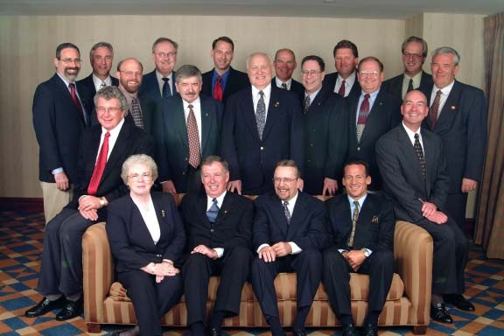

**International Door Association 2001 (Board of Directors)**

1st Row(Left to Right) - Inez Van Meter, Bill Winser, Mark Stuenkel, Steve Kalenich

2nd Row(Left to Right) - Keith Bomholt(sitting), Tom Schafer, Dennis Schlabach, Ed Niit, Henry Tarnow, Ted Billman, Jim Lett(sitting)

3rd Row(Left to Right) - Bill Wahler, Garry Stewart, Randy Moore, Randy Oliver, Jerry Buckley, Joe

Earwood, Joseph Chisholm, Michel Gendreau

HeritageoftheInternationalDoorAssociation

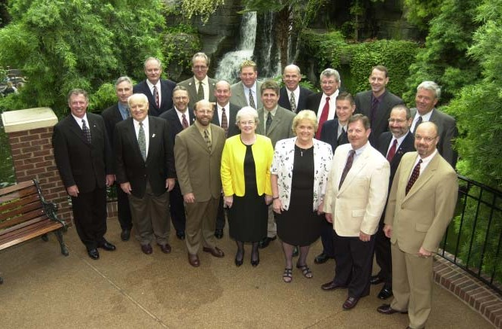

**International Door Association 2002 (Board of Directors)**

1st Row(Left to Right) - Bill, Winser, Ed Niit, Tom Schafer, Inez Van Meter, Luckie Jennings, Bob

Hammersley, Dan Beckley

2nd Row(Left to Right) - Garry Stewart, Mark Stuenkel, Jim Lett, Steven Harris, Dave Haslam, Bill Wahler

3rd Row(Left to Right) - Randy Moore, Joseph Chisholm, Joe Earwood, Jerry Buckley, Keith Bomholt, Randy Oliver, Michel Gendreau

2015 & 2016

**2015 Officers and Directors** President: Randy Oliver Past President: Bill Gibson Treasurer: Tim Matthews

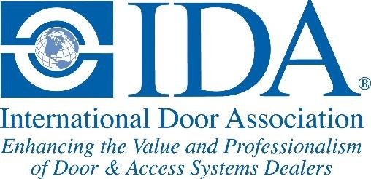

Dealer Member Vice President: Paul Peloquin

Industry Member Vice President: Flossie Mohler

Directors: Miguel Acosta Vega, Chuck Colton, Chris Cunningham, David Dawdy, Bob Hammersley, Ed Hermanns, Jennifer Juhlke, Gordon McGraw, Paul McManus, Keith Moore, Dan Nixa, Robin Oliver, Kevin Pettiette, Randy Schmitt, Jack Schram, Bill Wahler, Joel Yackee

Managing Director: Chris Long

**2016 Officers and Directors** President: Randy Oliver Past President: Bill Gibson

President-elect: Ed Hermanns

Treasurer: Tim Matthews

Dealer Member Vice President: Paul Peloquin

Industry Member Vice President: Flossie Mohler

Directors: Miguel Acosta Vega, Chuck Colton, David Dawdy, Bob Hammersley, Jennifer Juhlke, Jim McGinley, Jim McGrath, Gordon McGraw, Paul McManus, Keith Moore, Robin Oliver, Kevin Pettiette, Randy Schmitt, Jack Schram, Bill Wahler, Joel Yackee

Managing Director: Chris Long

**Recognition awards presented during the 2016 IDAExpo in Las Vegas:**

• Distinguished Service – Cathy Buckingham

• Joseph A. Caputo Dealer of the Year – Loren Vickers – Loren

Vickers Overhead Door

• Jerry R. Reynolds Volunteer Leadership – Keith Bomholt

• Presidential Service Award – Tim Matthews & Robin Oliver

• Industry Member Service Award – Rasco Industries

• Special Service Award – Rosita “Roe” Long-Wagner

• International Dealer – Avon Industrial Doors, Ltd. & PIA Dorp

Puertas Y Instalaciones Automaticas

• Heritage Award – The Fimbel Family

• Humanitarian Award – Mike McAlear – Service Spring Corp.

• Door Technicians of the Year – Jonathan Raymond Massey, Randy

Monks & Stephen Antle

• Tancil A. Horne Charity Award – Semper Fi Fund

• Director Service Award - Dan Nixa, Joel Yackee, Kevin Pettiette, Paul Peloquin, Ed Hermanns, Chris Cunningham

During our 2015-2016 fiscal year the association’s net revenue increased over $300,000 from the previous year. Our membership retention reached 91% and our membership high water mark was

1987 members. The “Future Leaders Group” continued to develop

and six members of the group attended the SPC meetings in February

2016 in San Diego. At this meeting the group officially changed their name to the “Young Professionals Network” (YPN). Initial discussions with the American Fence Association began to see if the IDAExpo and Fencetech could benefit from having co-located shows. The association had a very successful IDAExpo in Las Vegas in 2016 and Rosita (Roe) Long-Wagner was honored for her 30 years of dedicated

service to the association and our industry. I unfortunately missed this Expo because of a heart attack I suffered the Sunday before the Expo which made me the first IDA President ever to miss an entire Expo.

**Recognition awards presented during the 2017 IDAExpo in Atlanta:**

• Distinguished Service – Chuck Miller

• Joseph A. Caputo Dealer of the Year – Steve Pascuzzi – DH Pace

Company

• Jerry R. Reynolds Volunteer Leadership – Roy Bardowell

• Presidential Service Award – Flossie Mohler & Paul McManus

• Industry Member Service Award – Iowa Spring Manufacturing

• Globe Award – Bill Gibson

• International Dealer – Puertas Y Controles Automaticos & Overhead Door of Ireland

• Heritage Award – Heimer “Ed” Niit – Door Systems, Inc.

• Humanitarian Award – Justus Angan & Ron Read – RW Garage

Doors

• Door Technicians of the Year – Lawrie Theurer & Dan Schearrer

• High Roller Distinguished Service Award – LiftMaster & Denco

Marketing

• Tancil A. Horne Charity Award – Just 1 Book

• Director Service Award - Tim Matthews, Bob Hammersley, Gordon

McGraw, Jack Schram, Jennifer Juhlke, Miguel Acosta

The association experienced another good fiscal year in 2016-2017 with net revenues over $227,000. Membership retention reached

93% and our membership high water mark was 2072 members. We enjoyed a successful 2017 IDAExpo in Atlanta, GA and we experienced the best Expo party EVER at the Georgia Aquarium. Under Chuck Colton’s leadership, the IDA Scholarship Foundation developed the “Change a Life” fund raising initiative and a silent auction at the Expo that raised over $13,000 for the Scholarship Foundation. Discussions with the American Fence Association continued, and it was decided to co-locate the IDAExpo and Fencetech in Indianapolis in 2019 and Salt Lake City in 2020. The new IDA Education website was created so our membership and our industry could have easier access to educational opportunities. The Young Professionals Network (YPN) increased their participation in the association and we were very fortunate to have one of the original YPN leaders, Colleen Mooney, elected to the IDA board of directors.